***DataWorksAI* Text-to-SQL Chatbot Project Summary**

## **Table of Contents:**

## Abstract

## Introduction

* 1. Data Observation
  2. Overview of LLM
  3. Standard Techniques and Architectural Patterns
  4. LLM models used

## Preliminary

* 1. Prerequisites
  2. Experimental Setup

## Methods

* 1. Techniques and Architecture
     1. Concepts
     2. Langchain Architecture
     3. LlamaIndex Architecture
  2. Frameworks and Orchestration Tools
     1. Langchain
     2. LlamaIndex
     3. Streamlit
     4. Tracing with Langsmith
     5. Tracing with Phoenix
  3. Implementation with Langchain
  4. Implementation with LlamaIndex

## Results and Discussion

## Evaluation and Testing

* 1. Testing with Langsmith and Phoenix
  2. Accuracy
  3. Execution Time
  4. Tokens Utilized
  5. Usage Cost

1. Deployment and Hosting
2. Limitations

## Conclusion

1. Future Scope
2. Glossary
3. Appendix

## Abstract

The Text-to-SQL problem has significantly improved due to large language models (LLMs). Yet, the lack of a standard benchmark makes it challenging to create effective and affordable LLM-based solutions. This study investigates how the Transformer architecture, the foundation of LLMs, may be used to turn natural language into SQL queries. Transformers use a self-attention technique that enables the model to record complex relationships and contextual details, resulting in more accurate and suitable translations for the context. The suggested method makes use of this ability and seeks to maximize the accuracy and efficiency of Text-to-SQL infrastructures by utilizing Transformer-based LLMs.[1]

Several prompt engineering strategies, including question representation, example selection, and organization, were compared to address this difficulty. The methodology's advantages and disadvantages were verified through thorough testing.

Building on these insights, we introduce a lightweight and easily deployable solution that leverages Langchain and LlamaIndex[2]. Langchain is an open-source orchestration framework facilitating the development of applications utilizing LLMs, while LLamaIndex provides essential tools for data ingestion, structuring, retrieval, and integration with diverse application frameworks. Employing the OpenAI GPT-3.5 Turbo LLM model, alongside explorations into integrations with the LLama2 model, we aim to provide instant responses and support for Information Retrieval and Academic Support. This entails the DataworksAI chatbot acting as a virtual assistant, offering swift and accurate responses to inquiries regarding admissions, programs, course registration, financial aid, and campus amenities, utilizing IPEDS survey data, and reducing reliance on manual searches.

Furthermore, we investigate the potential of open-source LLMs across diverse scenarios, enhancing their performance through supervised fine-tuning. Our research highlights the promise of open-source LLMs in Text-to-SQL applications while also discussing the benefits and drawbacks of supervised fine-tuning. Additionally, we underscore the importance of token efficiency in prompt engineering, comparing previous studies based on this metric.

## **Introduction**

Artificial Intelligence (AI) encompasses developing systems and machines that perform tasks requiring human-like intelligence. Machine Learning (ML) is a subset of AI focused on algorithms and statistical models enabling computers to learn from data without explicit programming. Within ML, Deep Learning (DL) employs neural networks with multiple layers to learn complex representations from data. The Transformer architecture is a specific DL architecture notable for its self-attention mechanism, which is particularly effective in handling sequential data, such as natural language processing tasks. AI encompasses the broader goal, ML provides the tools for learning from data, DL refines those tools with deeper architectures, and the Transformer architecture offers a specialized approach for sequential data processing within deep learning.

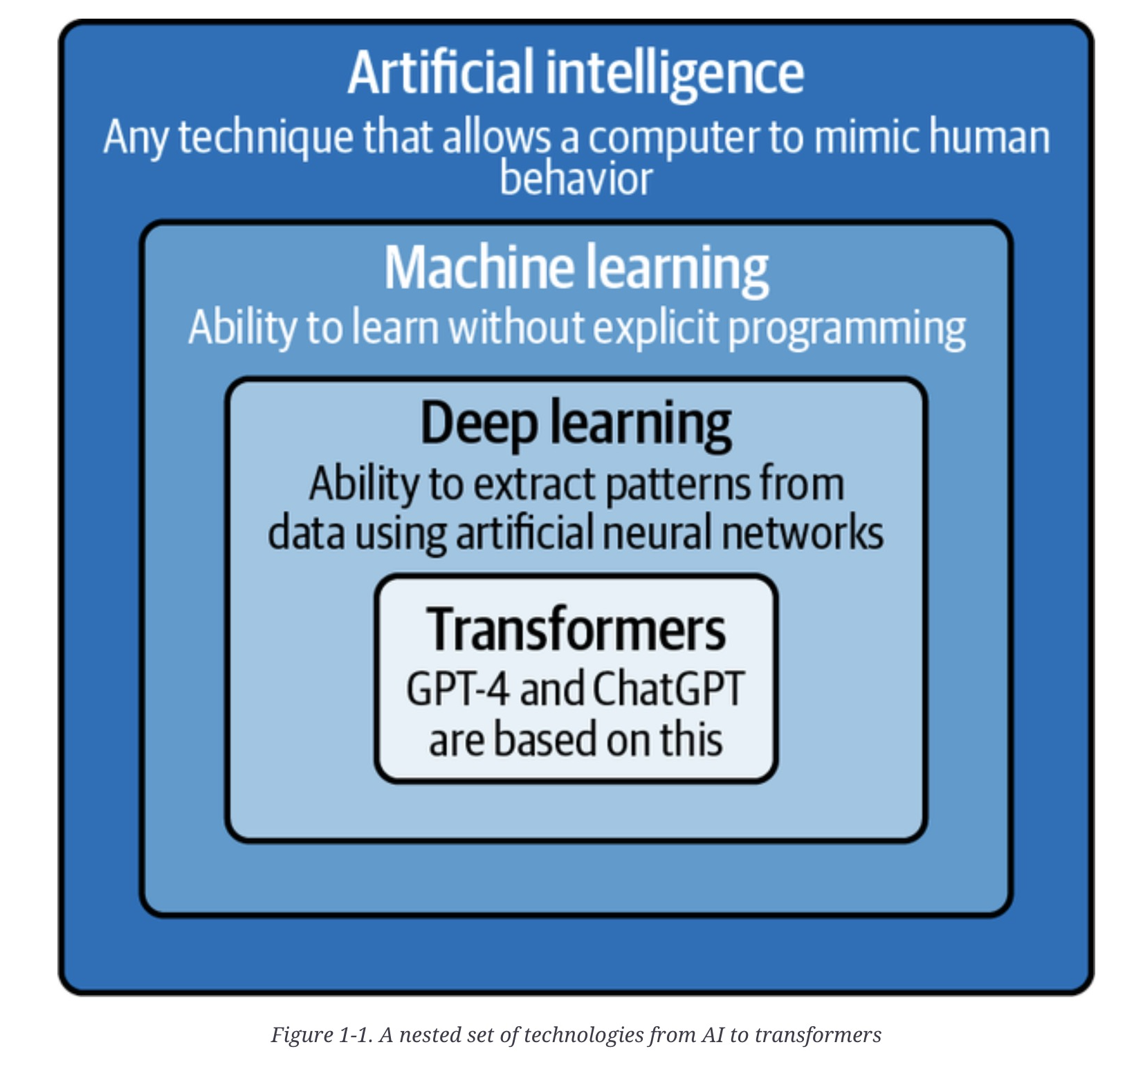

*Fig. 1. xxx [3]*

Chat Model definition.

Extensive research has been conducted in database and natural language processing communities, employing techniques ranging from rule-based systems to sequence-to-sequence models.

With the advent of DL, attention mechanisms, graph representations, syntax parsing, and models like Bidirectional Encoder Representations from Transformers (BERT) have been applied to enhance text-to-SQL performance. Large language models (LLMs), mainly referred to as transformer-based pre-trained neural language models (PLM), are trained on massive text data. LLMs contain tens to hundreds of billions of parameters. LLMs are larger in model size and exhibit more robust language understanding, generation, and emergent abilities that are not present in smaller-scale models. There are three LLM model families: GPT, LLaMA, and PaLM,[4]

GPT-4 is the latest and most powerful LLM in the GPT family. Launched in March 2023, GPT-4 is a multimodal LLM in that it can take image and text as inputs and produce text outputs. GPT-4 exhibits human-level performance on various professional and academic benchmarks, including passing a simulated bar exam with a score around the top 10% of test takers, Like early GPT models, GPT-4 was first pre-trained to predict next tokens on large text corpora, and then fine-tuned with RLHF to align model behaviors with human-desired ones. OpenAI reports that the much smaller GPT-3.5 Turbo model can outperform GPT-4 when fine-tuned with task specific data This project uses the GPT-3.5 Turbo model from Open AI

DataworksAI’s Text-to-SQL chatbot project seeks to bridge the knowledge gap between database systems and non-expert users by automating the translation of natural language questions into SQL queries. This project leverages the power of LLMs to advance the Text-to-SQL task, improve the effectiveness of data processing, and open up various applications, such as automated data analysis, intelligent database services, and query response.

From this project, we learned that developing text-to-SQL chatbots can be challenging and that the existing technologies have a lot of drawbacks. This is true, even with the availability of Prompt Engineering techniques and powerful LLM to support text-to-SQL intermediate tasks. These mainly relate to how difficult it is to understand natural language queries and produce accurate SQL queries properly. Prompt engineering is crucial for utilizing LLMs in text-to-SQL, where the optimal prompt is essential for effective operation. Furthermore, in-context learning, exemplified by example selection and organization, plays a pivotal role in LLMs' ability to adapt to new tasks during inference. Although LLMs exhibit effectiveness in zero-shot and few-shot scenarios, their performance can be further enhanced through supervised fine-tuning.

This project aims to systematically study and discuss question representation, in-context learning, and supervised fine-tuning as fundamental aspects of LLM-based Text-to-SQL.

In-context learning involves contextual details to refine understanding and improve accuracy, particularly in tasks like Text-to-SQL, where complex relationships and nuances are crucial. On the other hand, supervised fine-tuning enhances model accuracy and applicability in targeted applications, such as Text-to-SQL, by tailoring parameters to domain-specific requirements, thus improving the model's ability to generate precise and contextually relevant responses.

While LLMs offer an intuitive natural language interface between humans and data, they lack access to specific private or domain-specific data crucial for accurate text generation. Unlike publicly available data sources such as Wikipedia or textbooks, private or proprietary data may reside behind APIs, SQL databases, PDFs, and slide decks. While fine-tuning an LLM entails customizing the pre-trained model for particular tasks. LLM fine-tuning involves adjusting parameters based on a new dataset, where the LLM undergoes partial retraining using <input, output> pairs exemplifying the desired behavior; it poses challenges such as high training costs, difficulty updating the latest information, and limited observability of the model's decision-making process.[5]

In contrast, the context augmentation pattern of Retrieval-Augmented Generation (RAG) offers a viable alternative: adding more information or data to the input context to improve the model's comprehension and performance, resulting in more accurate and contextually relevant outputs. RAG involves retrieving information from appropriate data sources, incorporating it into the query context, and prompting the LLM to generate text based on the enriched prompt. This approach addresses the limitations of fine-tuning by offering cost-effectiveness, real-time data relevance, and enhanced trustworthiness through observable retrieval mechanisms.

Moreover, the DataworksAI chatbot's knowledge base, crucial for accurate responses, is obtained through a data dictionary, serving as a source of structured information about the database schema, tables, and columns. The data dictionary available with the public data sources is the foundation for the RAG implementation for the DataworksAI chatbot's knowledge base.

RAG combines retrieval-based methods with generative language models to provide contextually relevant information. In this scenario, the RAG component retrieves relevant passages or documents from the data dictionary based on the user's query, augmenting the DataworksAI chatbot's understanding and ability to generate accurate SQL queries.[6] By leveraging the structured information provided by the data dictionary, RAG enhances the DataworksAI chatbot's capability to interpret and respond to natural language inquiries effectively within the context of the database schema.

RAG implementation with the Langchain framework typically employs a series of architectural patterns to achieve its objectives *(Fig.3)*. Data retrieval involves interfacing with the SQL database through LangChain to extract relevant information based on user queries, utilizing SQL queries for efficient data extraction. Subsequently, data processing occurs to format the retrieved data dictionary into a suitable structure like JSON, ensuring compatibility with the LLM. Query augmentation follows, wherein the processed data enriches the user's original query, providing additional context for the LLM. Finally, response generation utilizes the augmented query to prompt the LLM to generate contextually relevant responses. Integrating these steps into a seamless workflow facilitated by LangChain orchestrates the interaction between the LLM and the SQL database, embodying a typical architectural pattern for RAG implementations.

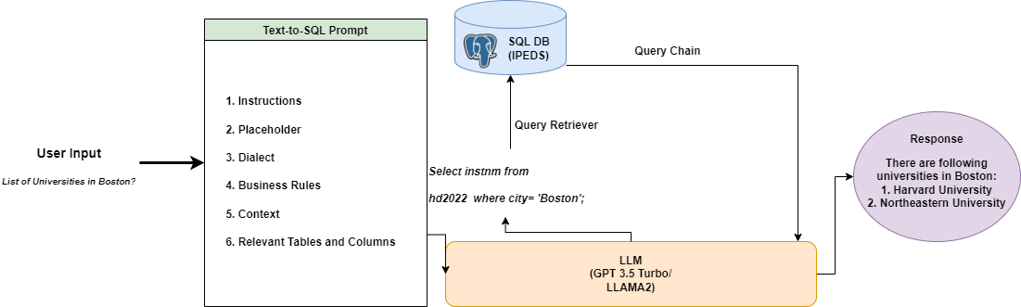

*Fig.3; Basic Workflow of Text-to-SQL Architecture*

Text-to-SQL is a natural language processing task automatically generating Structured Query Language (SQL) queries from natural language text.

The process begins with the user inputting a natural language question from the generated SQL Query chain. The SQL Query chain then utilizes an LLM to analyze the question and identify the user's intent, the relevant database tables and columns, and the necessary filters, aggregations, and other SQL constructs to answer the query. The SQL Query chain leverages the LLM again to format the results in a user-friendly way, potentially generating a natural language summary or explanation of the data. Finally, the SQL Query chain presents the final answer to the user, displaying the relevant data and any additional context or explanation.

This end-to-end process allows users to ask questions simply in natural language. The SQL Query chain handles the translation to SQL and the answer generation using advanced language models and iterative query refinement.

The LlamaIndex[7] Query Pipeline facilitates Text-to-SQL transformation with query-time table retrieval and Retrieval Augmented Generation (RAG).[8] The process encompasses several core modules. Firstly, user input is received in natural language. Next, an ObjectIndex coupled with a retriever is employed to store table schemas, facilitating efficient retrieval during query processing. An SQL database object establishes connections with the specified tables, while an SQLRetriever fetches relevant data. Subsequently, a Text-to-SQL prompt is generated to convert the user's natural language query into SQL format. A Response synthesis prompt is crafted to create coherent responses based on the SQL query results. Finally, the pipeline leverages the GPT-3.5 turbo LLM model to execute these tasks seamlessly. This comprehensive process ensures effective handling of user queries, retrieval of necessary data, SQL query formation, and synthesis of informative responses, thereby enhancing the efficiency and usability of the Text-to-SQL system.

## APLC™ Quadrant framework

To build the Dataworks Text-to-SQL chatbot, the Analytics Product Life Cycle™ (APLC), a framework developed by Hema Seshadri, Ph.D., was used to break down this complex project into smaller manageable segments or quadrants.[9] The four quadrants include

* Business Quadrant
* Data Engineering Quadrant
* Modeling Quadrant
* Software Engineering Quadrant

The following sections will review the specific steps in each quadrant.

## Business Quadrant

According to the *“Analytics for Business Success”* by Hema Seshadri, Ph.D, the business quadrant is the first stage in the Analytics Product Life Cycle (APLC), where the said project team tackles the obstacles hindering the tasks of problem setting and project sizing.[10] The inclusion of a business quadrant is more crucial as it will provide a view of how the decisions and actions all merge well with APLC through the steps provided:

**Choose a Small But High-Impact Problem**

To find a small but significant problem, improving the performance and accuracy of text-to-SQL systems should be concentrated primarily, especially in the context of conversational AI chatbots. The aim is to optimize the conversion of natural language questions into SQL queries, reduce the knowledge gap between non-technical users and database systems, and promote more user-friendly and accessible data interactions.

**Frame the Business Problem**

The primary source of the business issue is the pressing requirement for more effective and user-friendly ways for people who need to be specifically skilled in SQL to interact with databases. Because they need domain-specific knowledge and skill sets, traditional database querying techniques can create an access barrier. We aim to close this gap and give consumers a smooth and user-friendly platform for natural language database queries by utilizing the power of complex analytics models made possible by the LangChain and LlamaIndex frameworks.

**Define Success**

Implementing a text-to-SQL DataworksAI DataworksAI chatbot that is fully functional and able to interpret natural language requests and produce SQL queries that retrieve relevant data from the database demonstrates the achievement of this task. The accuracy with which the DataworksAI chatbot understands user inquiries, the effectiveness with which SQL queries are formulated, and the degree to which users are satisfied with the DataworksAI chatbot's replies are critical success metrics. Success ultimately depends on the DataworksAIchatbot's capacity to expedite data access and analysis procedures, enhancing end users' productivity and decision-making ability.

**Evaluate Organizational Culture**

A rigorous examination of the organizational culture is necessary to determine how prepared the business is for innovation and adopting new technology. Text-to-SQL DataworksAI chatbots and other sophisticated analytics models can only be successfully implemented in an environment that strongly emphasizes collaboration, open-mindedness, and continual learning. Open communication channels, a willingness to adapt, and a steadfast commitment to user-centric design principles are characteristics of an environment that fosters innovation and development.

**Identify the Sponsor**

The text-to-SQL DataworksAI chatbot's development and deployment can be accelerated by the technological know-how, support infrastructure, and resources provided by the DataworksAI team, which steps in as the project sponsor. To lead the project to completion, DataworksAI combines technical mastery, subject understanding, and strategic vision as the organization's leading AI and data analytics team. With their support, we can apply cutting-edge approaches and technology to solve urgent business issues and provide clear benefits to end users.

## Data Engineering Quadrant

Data engineering is essential for an LLM project to be successful and productive. This is especially true for Text-to-SQL DataworksAI chatbots. Data engineers establish the framework for developing, implementing, and maintaining a successful model. They create accurate, dependable, and actionable insights for LLMs by efficiently managing and analyzing data, adding value for businesses in various industries.

Data Engineering has four crucial steps, which are

1. Data Discovery
2. Data Collection
3. Data Processing and Transformation
4. Data loading and maintenance

**Data Discovery**:

The Integrated Postsecondary Education Statistics System (IPEDS) survey serves as a vital resource, offering comprehensive statistics on postsecondary education in the US, essential for academic institutions, legislators, researchers, and the public. It furnishes diverse data like enrollment figures, graduation rates, financial aid details, faculty profiles, and institutional characteristics, which are crucial for educational research, policymaking, and evaluating institutional efficacy. To develop the latest knowledge base to serve as a context for our DataworksAI chatbot, we have completed data gathering from 2022 to 2023. We decided to use the NCES data for the academic year 2021–2022, even though the data extended from 2004 to 2023. Considering the amount of data and the resources available for the project, we chose to use only a year's worth of data, which is sufficient for our idea of developing a DataworksAI chatbot. Our project aimed to utilize this tabular, structured data from the IPEDS survey to construct a DataworksAI chatbot for exploring Universities or Institutions based on various KPIs, facilitated by a Postgres database containing 21 tables with over 862,853 rows, 663 columns, and 118.4 MB size. The project's robust infrastructure and data retrieval mechanisms ensured seamless exploration and utilization of the dataset's vast information.

**Dataset Access and Availability:**

IPEDS releases the latest survey data through access dB files. For this implementation, we do not use access dB for various reasons. Access dB might lack the automation and scalability required for tasks demanding extensive data processing or integration with other systems, posing challenges compared to more robust database systems. Additionally, while suitable for small-scale projects, access dB may struggle with handling large datasets or concurrent user access, a capability offered by database systems like PostgreSQL designed for high performance and scalability. Lastly, PostgreSQL's array of advanced features such as support for complex queries and transactions, surpassing those of Access databases, made it the preferred choice. PostgreSQL's compatibility with Python, robustness, scalability, automation capabilities, and advanced features collectively rendered it better suited for the project's requirements, hence its selection as an alternative to the access dB. Our research utilizes PostgreSQL (version 8.2) database hosted by Digital Ocean[11] which provides services for hosting scalable databases. PostgreSQL offers a secure, scalable platform and support for complex queries. PostgreSQL's extensibility allows for customization, ensuring data accessibility and management. This approach supports our research objectives and demonstrates our commitment to using advanced technologies.

**Data Processing:**

One critical data processing step in the project was to modify the table structure and data format so the LLM models we employed could easily understand them, and the product was reliant on a much larger database. As this is not a machine learning predictive model, there is no need for preprocessing steps such as normalization, feature Engineering, etc. However, we must ensure the data is standardized across all the tables. We followed several steps to modify until the DataworksAI chatbot performance was accurate.

The tables needed more improvement since they had data type problems, missing values filled with characters, and other issues. This was necessary to ensure no runtime SQL query failures for the LLM model.

*Steps undertaken*:

* Proper design of the db/schema with appropriate table names, column names, and primary keys defined.
  + In the IPEDs data tables, UNIT_ID is the field that can be considered the primary key across all the tables.
  + We ensure no duplicate or null values are in the primary key column.
* Here are a few instances of data format.
  + In certain tables, the characters "." fill in the blank rows in the number columns where NULL or 0 should be.

For example in the table IC2022_campuses, as shown below in Fig 2, the format of data in the missing rows is all filled with ‘.’.

| PCCHG4AY3 | XPCCHG5AY0 | PCCHG5AY0 | XPCCHG5AY1 | PCCHG5AY1 |
| --- | --- | --- | --- | --- |
| 1300 | A | . | A | . |
| 1300 | A | . | A | . |
| 1320 | R | 11914 | R | 12364 |
| 1320 | R | 12728 | R | 13702 |

*Table 1. Sample Table IC2022_campuses before cleaning*

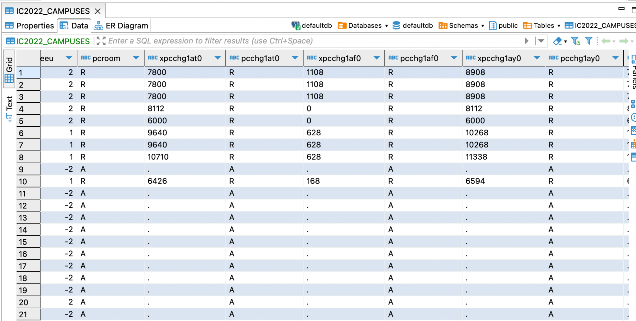

*Fig. 2; Table IC2022_campuses before cleaning*

This type of format is then cleaned and replaced with appropriate value, which is 0 as we can see in the below screenshot (Fig 3).

| PCCHG4AY3 | XPCCHG5AY0 | PCCHG5AY0 | XPCCHG5AY1 | PCCHG5AY1 |
| --- | --- | --- | --- | --- |
| 1300 | A | 0 | A | 0 |
| 1300 | A | 0 | A | 0 |
| 1320 | R | 11914 | R | 12364 |
| 1320 | R | 12728 | R | 13702 |

*Table 2. Sample Table IC2022_campuses after cleaning*

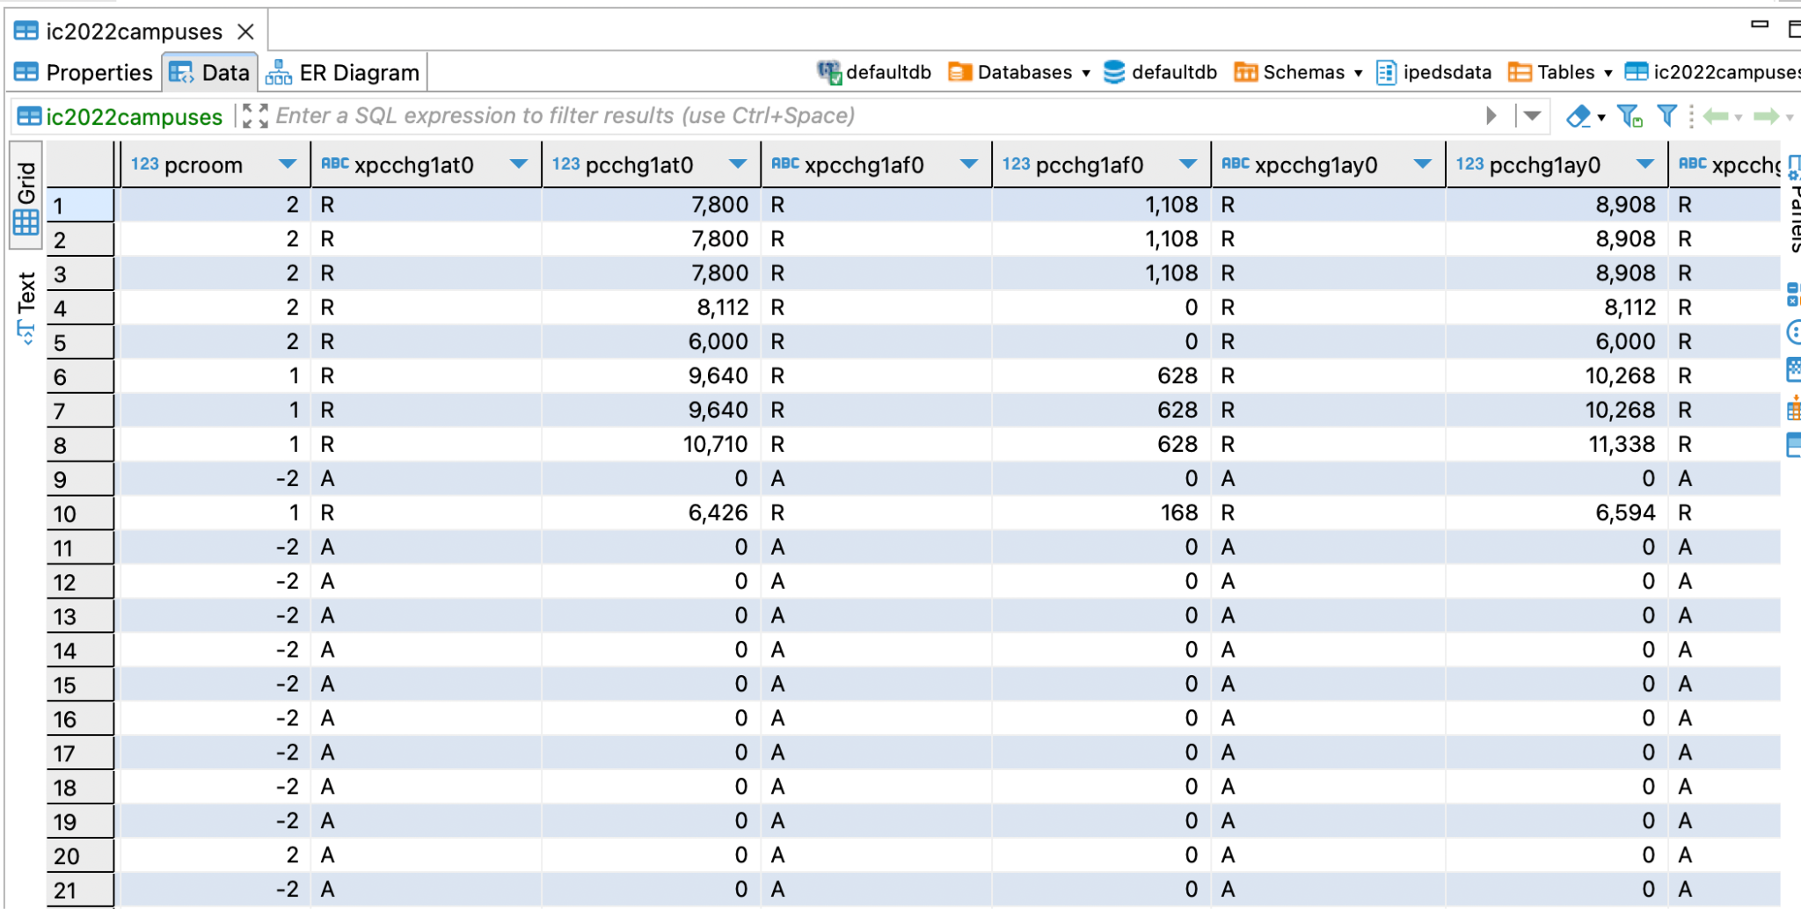

*Fig. 3; Table IC2022_campuses after cleaning*

* + Other instances when a special character "," such as ",25678," prefixed some integer fields in tables. To prevent these columns from being stored in text format, they were also fixed in the correct format.

In each dataset table, columns are assigned relevant abbreviations, such as 'stabbr' denoting state acronyms. This naming convention serves a dual purpose, offering advantages and limitations, particularly in Language Model (LLM) utilization. Abbreviated column names streamline data processing, simplifying loading and query execution within LLM models. However, these terse labels can occasionally obscure the precise context of a column, posing challenges for the LLM in accurately interpreting human-entered English queries. To address this, we've modified the column name to enhance the LLM's comprehension. By refining and standardizing column names, we aim to bridge the gap between human input and column semantics, ensuring the LLM can effectively match user queries to the appropriate data columns. This adaptation emphasizes our dedication to improving the LLM's performance and enhancing its usefulness in data retrieval and analysis.

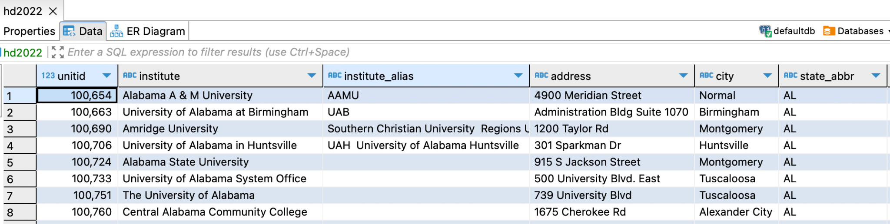

*Fig. 4; Sample of HD2022 - Modified Column names*

Although this approach was promising, it was not feasible for larger datasets, which was a huge disadvantage. Hence, we chose to use the [data dictionary](https://docs.google.com/document/d/1r58iMM5DGRTesu3DBeiGHwWFIshiixqYO4W739zuGHU/edit?pli=1#bookmark=id.elp0tr7xfzav), which contains all of the column details, in the LLM Python code due to the data's complexity with label encoding.

**Data Loading:**

Either the raw format of the data or the necessary formatting can be applied before loading it into the Postgres database. We can use tools like Dbeaver or Pgadmin to connect to a Postgres database. The appendix section contains the comprehensive installation instructions. Once the database is connected,

{HS>>Grab relevant content <https://learning.oreilly.com/library/view/building-llm-apps/9781835462317/text/ch009.xhtml#overview-of-the-chinook-database> } Rewrite in your own words.

SQLAlchemy: This is an open-source SQL toolkit and object-relational mapper (ORM) for Python. It allows you to create, read, update and delete data from relational databases using Python objects and methods. It supports many database engines, such as SQLite, MySQL, PostgreSQL, Oracle, and more.

* psycopg: This is a popular database connector for PostgreSQL. It enables you to execute SQL queries and access PostgreSQL features from Python. It is fast, reliable, and thread-safe.

we may load the raw or formatted tables into the appropriate schema as needed. The appendix provides a detailed explanation of the data loading procedure as well.

The following additional techniques are helpful to prepare the data for LLM models which we will go into in the Techniques and Architecture segment.

*HS> Please list out the SQL agent and other Data engineering Quadrant techniques.*

#### Data Connections[12]

HS> <https://learning.oreilly.com/library/view/building-llm-apps/9781835462317/text/ch006.xhtml#technical-requirements-4>; Chapter V

Diagram: <https://python.langchain.com/docs/modules/data_connection/>

### 

### Vector Stores[13]

HS> *Figure 3: Sample architecture of vector store. Source: https://python.langchain.com/docs/modules/data_connection/vectorstores/*

### Retrievers[14]

### Difference between Retrievers and Vector stores[15]

## Data Modeling Quadrant:

The Data Modeling Quadrant is a pivotal phase in advanced analytics projects, especially in LLMs for Text-to-SQL applications. With the significant advancements by LLMs, such as the Transformer architecture, which excels in capturing complex relationships and contextual nuances, a need arises to harness these capabilities effectively. However, the absence of standardized benchmarks poses a challenge in devising efficient LLM-based solutions. Various prompt engineering strategies have been explored to address this challenge, encompassing question representation, example selection, and organization, with their respective advantages and drawbacks verified through rigorous testing. Expanding on these findings, we propose a lightweight solution facilitated by Langchain, an orchestration framework, and LLamaIndex, a comprehensive data management toolkit. By integrating the OpenAI GPT-3.5 Turbo LLM model, we aim to enhance Information Retrieval and Academic Support functionalities within the DataworksAI chatbot. Leveraging IPEDS survey data, this chatbot acts as a virtual assistant, offering swift and accurate responses on admissions, programs, course registration, financial aid, and campus amenities, thereby reducing reliance on manual searches. Furthermore, our research delves into the potential of open-source LLMs across various scenarios, emphasizing the role of supervised fine-tuning in enhancing performance while also addressing token efficiency in prompt engineering methodologies.

Our implementation of the text-to-SQL model is a deep learning-based model consisting of two main components: an encoder and a decoder. The encoder produces vector representations that capture the language and structure of the queried table. Meanwhile, the decoder leverages these vector representations to convert the input natural language into SQL queries.

## **Preliminary**

Pre-trained LLM models comprise various components designed to execute diverse functions, from data interpretation to generating pertinent outputs. These models consist of four principal components:

1. Embedding layer: This layer transforms input data, typically comprising words or phrases, into numerical vectors, encapsulating their semantic meaning. It serves as the foundation for subsequent computations and significantly influences model performance. Transformer-based models like GPT and BERT autonomously generate robust embeddings during pre-training, distinguishing them from standalone embedding models like Word2Vec and GloVe.
2. Self-attention mechanism: This element enables the model to discern the importance of individual words within a sentence when constructing a representation for a specific word. It facilitates selective focus on distinct parts of the input during processing by assigning relevance scores to each word and subsequently combining their representations in a weighted manner.
3. Encoder or decoder blocks: These constitute the model's core components, comprising a self-attention layer and a feed-forward neural network. Encoder blocks convert input data, often in word embeddings, into a higher-level representation, capturing contextual relationships between words. Conversely, decoder blocks utilize encoded information to generate outputs, such as predicting the subsequent word in language modeling tasks. While BERT and RoBERTa employ multiple stacked encoder blocks, GPT utilizes decoder blocks.
4. Output layer: As the final component, this layer transforms the high-level representations generated by encoder or decoder blocks into the ultimate output. The specific nature of this output varies depending on the task at hand, ranging from probability distributions for language modeling to class probabilities in classification tasks. Typically, the output layer comprises a dense layer followed by a softmax function for normalization.

Pre-trained models offer the flexibility of fine-tuning for specific tasks, conserving time and computational resources. The selection of an appropriate pre-trained model hinges on factors such as model size, performance on benchmark tasks, the necessary fine-tuning resources, and the characteristics of the original training data. When developing LLM-powered applications to enhance development productivity, options include GPT, Codex, BERT, RoBERTa, and T5.

LangChain is an open-source platform tailored for LLM application development, offering streamlined API usage, memory management, chaining capabilities, and agent interactions. Hugging Face Transformers stands out as a comprehensive library providing numerous pre-trained models applicable across text, speech, vision, and tabular data domains, with functionalities spanning classification, information extraction, summarization, translation, and text generation. Additionally, it facilitates training, fine-tuning, and deployment of these models.

LlamaIndex offers a specialized data framework for LLM applications.[16] It mainly focuses on efficient data retrieval and response aggregation, enhancing text-to-SQL capabilities. This framework integrates user input processing, indexing of objects, SQL database connectivity, text-to-SQL transformation, and response synthesis, leveraging LLM to execute tasks seamlessly.

Python tools remain viable for custom model development due to their simplicity, versatility, and extensive library support for machine learning and AI tasks. TensorFlow and PyTorch, in particular, furnish robust tool sets for constructing and refining LLMs to meet specific project requirements.

## Key LLM Techniques and Architecture

LLM models are composed of several key techniques and architecture that work together to enable them to understand, generate, and translate human text with remarkable fluency and accuracy, finding diverse [real-world applications of LLMs](https://www.appypie.com/blog/top-10-real-world-applications-of-large-language-models). Let’s understand what the components of Large Language Models (LLMs) are:

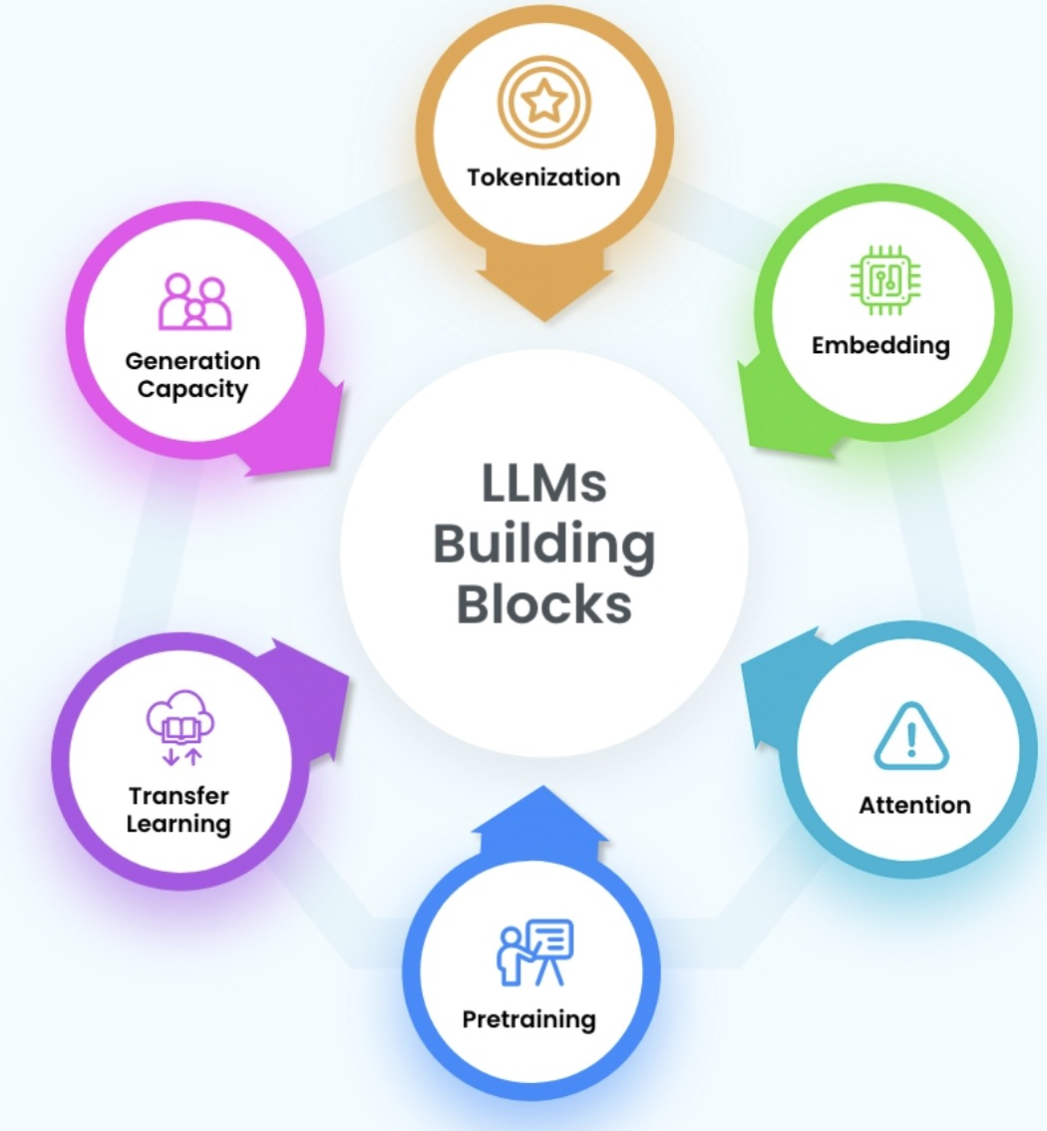

#### Components

##### Transfer Learning

Transfer learning, a cornerstone in modern AI, harnesses prior knowledge from disparate contexts, whether distinct tasks, languages, or domains, to tackle present challenges more effectively. Inspired by the cognitive processes of human learning, it mirrors our inclination to build upon existing knowledge rather than starting from scratch for each new endeavor.

*“Transfer learning enables you to adapt or transfer the knowledge acquired from one set of tasks and/or domains to a different set of tasks and/or domains. What this means is that a model trained with massive resources—including data, computing power, time, and cost—which were once open sourced can be fine-tuned and reused in new settings by the wider engineering community at a fraction of the original resource requirements. This represents a big step forward for the democratization of NLP and, more widely, AI. This paradigm is illustrated in figure 1.1, using the act of learning how to play a musical instrument as an example. It can be observed from the figure that information sharing between the different tasks/domains can lead to a reduction in data required to achieve the same performance for the later, or downstream, task B.”[17]*

This approach empowers practitioners to repurpose knowledge acquired from one set of tasks or domains to address entirely different challenges. Consequently, models initially trained with substantial resources comprising extensive data, computational power, time, and expense can be fine-tuned and repurposed within novel contexts by the broader engineering community, necessitating only a fraction of the original resource investment. Such democratization of resources marks a significant advancement in the accessibility of NLP and broader AI domains.

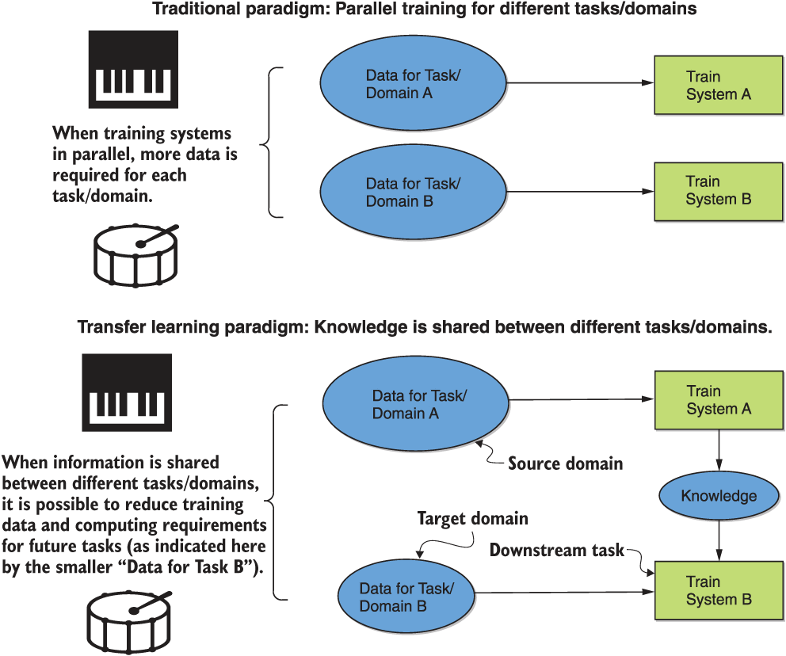

##### *Fig. 5; Comparison of Traditional and Transfer Learning Paradigms[18]*

### Vector Embeddings

##### Attention Mechanism

The attention mechanism is crucial in enhancing various natural language processing tasks, including text classification. The attention mechanism improves the performance of encoder-decoder (seq2seq) models by allowing the decoder to focus on specific parts of the input sequence during the decoding process. In the RAG architecture, the attention mechanism enables the model to dynamically weigh the importance of different parts of the input sequence (in this case, the text being classified) when making predictions. Instead of treating all input parts equally, the attention mechanism allows the model to focus more on relevant information and ignore irrelevant or redundant information.

When applied to text classification, the attention mechanism helps the model identify and prioritize critical features or words in the input text that indicate the class label. This is particularly useful when dealing with long or complex texts where not all words contribute equally to the classification decision.

##### Transformer Architecture

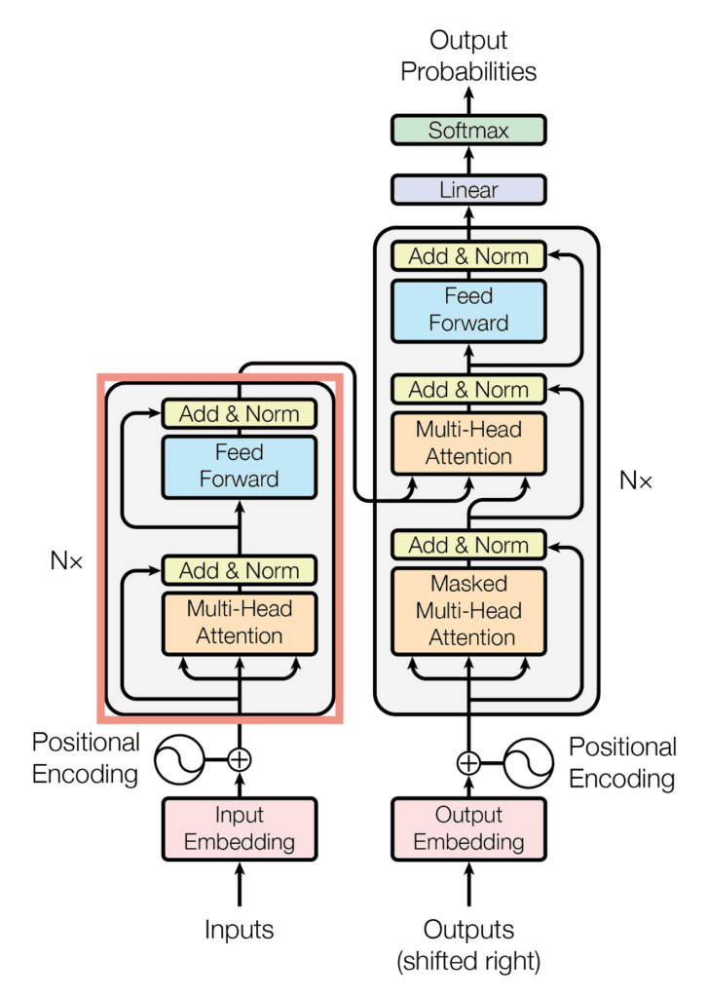

*Fig. 6; Transformer Model Architecture[19]*

The Transformer architecture, introduced in the seminal paper "Attention Is All You Need" in 2017, revolutionized NLP by offering a novel approach to sequence-to-sequence modeling without relying on recurrence or convolutions.[20] Comprising an encoder-decoder structure, the Transformer architecture aims to map input sequences to output sequences by leveraging attention mechanisms. The encoder, situated on the left half of the architecture, processes input sequences to generate continuous representations, which are subsequently fed into the decoder. In contrast, the decoder on the right half generates output sequences based on the encoder's representations and previous decoder outputs.

The key feature of the Transformer is its auto-regressive nature, where each step of the model consumes previously generated symbols to inform the generation of the next. The encoder consists of multiple layers containing sublayers for multi-head self-attention and fully connected feed-forward networks. Similarly, the decoder comprises identical layers with additional sublayers for masked self-attention, enabling unidirectional processing to prevent information leakage from future tokens. Notably, positional encodings are injected into input embeddings to convey sequence information, compensating for the absence of recurrence. In summary, the Transformer model transforms input words into embedding vectors, augmenting them with positional information, passing them through encoder and decoder blocks, and generating predictions through fully connected layers and softmax activation, enabling efficient and effective sequence modeling in NLP tasks.

##### Prompt Engineering

Prompt engineering is crafting input instructions or examples to guide the response generation of language models. It involves creating structured prompts that enable the model to understand the context and generate coherent outputs. This technique is crucial in fine-tuning models for specific tasks, such as Text-to-SQL, where the model needs to comprehend natural language queries and produce SQL queries accurately. Prompt engineering encompasses various strategies, including providing few-shot examples, where a small set of input-output pairs guides the model's completion, and dynamically selecting relevant examples based on the input. These prompts are designed to optimize the model's performance and ensure that it produces contextually appropriate responses across various applications and domains.

### Tokenization

*HS> Tokenization should go here.*

*Fig 3.2 has a good diagram* [*https://learning.oreilly.com/library/view/generative-ai-on/9781098159214/ch03.html#tokenizers*](https://learning.oreilly.com/library/view/generative-ai-on/9781098159214/ch03.html#tokenizers)

*Chapter 1- Demystifying Tokenization has a summary and diagram*

[*https://learning.oreilly.com/library/view/developing-apps-with/9781098152475/ch01.html#demystifying_the_tokenization_and_prediction_steps*](https://learning.oreilly.com/library/view/developing-apps-with/9781098152475/ch01.html#demystifying_the_tokenization_and_prediction_steps)

*HS> Fig 3.3 has a good diagram* [*https://learning.oreilly.com/library/view/generative-ai-on/9781098159214/ch03.html#tokenizer*](https://learning.oreilly.com/library/view/generative-ai-on/9781098159214/ch03.html#tokenizers)

##### Text-to-SQL

Text-to-SQL is a computational task within NLP aimed at automating the generation of SQL queries from natural language. In technical implementation, Text-to-SQL systems typically employ LLM to bridge the semantic gap between natural language and database queries. These systems consist of multiple components: a natural language understanding module for parsing user queries, a semantic parser for mapping parsed utterances to SQL queries, and a database execution engine for executing the generated SQL queries on the underlying database. The natural language understanding module preprocesses and tokenizes user queries, extracting important linguistic features and encoding them into a format suitable for the semantic parser. The semantic parser then utilizes a neural network architecture, such as a Transformer-based model, to generate SQL queries based on the encoded representations of the input utterances. This process involves learning the syntactic and semantic patterns present in the training data to translate natural language expressions into executable SQL commands accurately. Once the SQL query is generated, it is executed against the database, and the results are returned to the user.

##### Fine Tuning

Fine-tuning strategies are crucial in enhancing the performance of pre-trained language models (LLMs) for specific tasks. Once a pre-trained model is chosen, the subsequent step involves selecting an appropriate fine-tuning approach. This stage significantly influences the model's efficacy in the intended application domain. Several notable fine-tuning techniques include LoRA, QLoRA, few-shot learning, and basic hyperparameter tuning.

LoRA, short for low-rank adaptation, offers a parameter-efficient method for fine-tuning LLMs, particularly suitable for resource-constrained environments. It employs low-rank decomposition to represent weight updates, enhancing efficiency while maintaining performance across various tasks. Conversely, QLoRA leverages 4-bit quantized models to achieve high accuracy with minimal memory utilization, incorporating techniques like 4-bit NormalFloat quantization and paged optimizers to mitigate memory constraints.

Few-shot learning facilitates task adaptation by providing the model with a few examples during inference, guiding predictions through contextually embedded prompts. Meanwhile, basic hyperparameter tuning involves manual adjustment of hyperparameters, offering simplicity at the cost of potential inefficiency due to trial and error.

Ultimately, a fine-tuning approach hinges on task objectives, model choice, computational resources, and data availability. Each method presents trade-offs regarding efficiency, resource utilization, and performance optimization.

Selecting the appropriate framework or orchestration tool significantly impacts an LLM project's development, efficiency, and security measures. The chosen framework governs the entire lifecycle of LLM development, encompassing data handling, embedding, storage, training, fine-tuning, logging, API integration, and validation. Many options exist, including Python tools (e.g., TensorFlow, PyTorch), LangChain, LlamaIndex, Hugging Face Transformers, and ChatGPT.

##### Directed Acyclic Graphs (DAG)

Directed Acyclic Graphs (DAGs) are fundamental concepts in graph theory and computational science, particularly in NLP. A DAG is a directed graph without cycles, meaning no paths lead back to a node. In NLP, DAGs are commonly used to represent syntactic structures, semantic dependencies, and computational workflows. For example, in syntactic parsing, a DAG can represent the hierarchical structure of a sentence, with words as nodes and syntactic relationships as directed edges. Similarly, in semantic analysis, DAGs can model the dependencies between words and their semantic roles. DAGs are also utilized in various NLP algorithms, such as dynamic programming-based approaches for sequence alignment and parsing, where the acyclic nature of DAGs enables efficient computation and prevents redundant calculations. Overall, DAGs are potent tools for representing and processing linguistic information in NLP tasks, facilitating efficient algorithms and insightful analyses of textual data.

*HS> add Diagram*

1. **Retrieval Augmented Generation (RAG)**

The retrieval augmented generation (RAG) approach tackles key hurdles LLM applications encounter. Primarily, it addresses the issue of limited access to custom data, wherein LLMs trained on extensive datasets need help accessing organization-specific or domain-relevant information, resulting in static responses or inaccuracies when confronted with unfamiliar data. Additionally, RAG meets the demand for customization in LLM applications, which is essential for providing tailored responses in domains like customer support bots or internal question-and-answer systems. By integrating custom data into LLM-based systems through augmenting prompts with relevant information retrieved from organizational databases or knowledge bases, RAG enables dynamic access to real-time data, enhancing the performance of static LLMs, meaning they do not involve real-time adaptation or frequently re-trained.

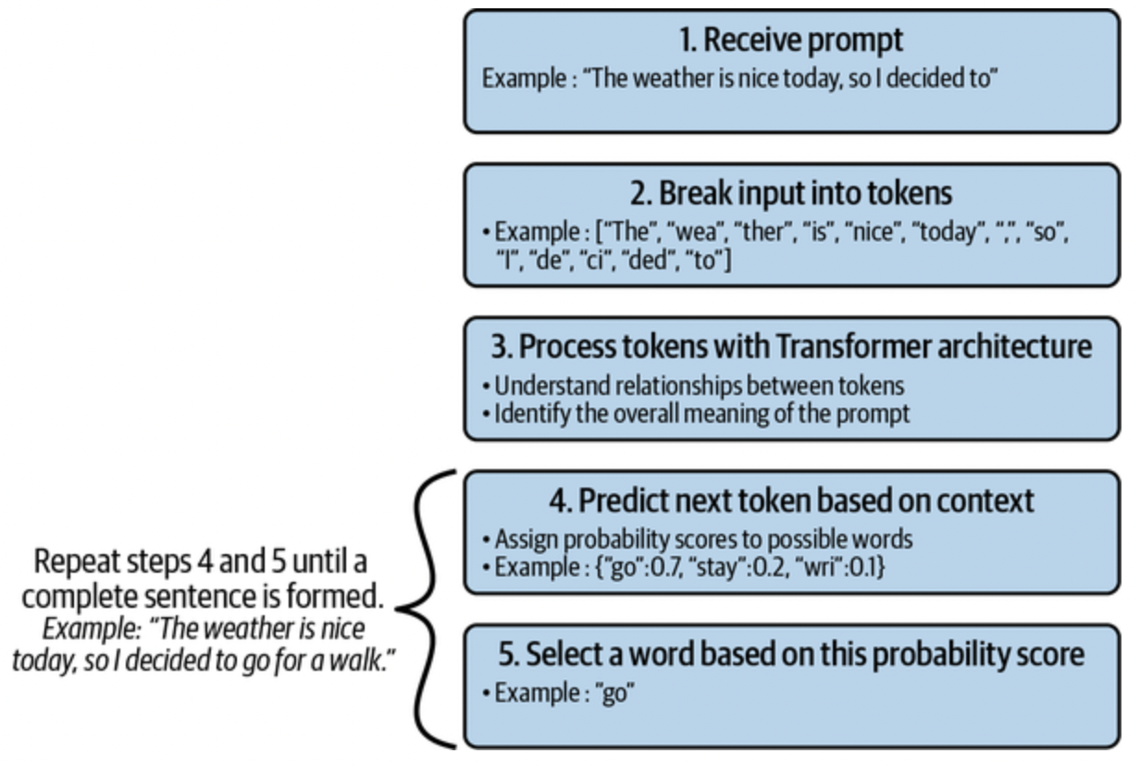

*Fig. 7; Text Generation Process Using Transformer Architecture[21]*

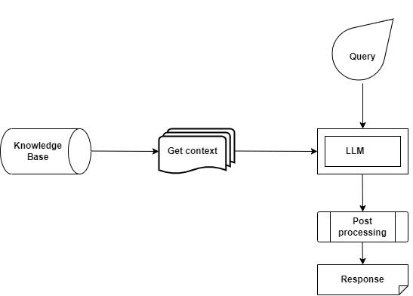

*Fig. 8; Retrieval Augmented Generation*

* In a text-to-SQL DataworksAI chatbot application, the RAG framework can act as a knowledge base by providing relevant passages or documents from a database. The DataworksAI chatbot can then use these SQL queries to generate SQL queries. The DataworksAI chatbot presents these SQL queries as responses to the user, potentially incorporating explanations from the retrieved passages to aid understanding. This approach facilitates seamless interaction with the database using natural language queries.

### 

### Vector Stores

#### Techniques

1. **Chains**

In the LangChain framework, chains refer to sequences of commands, such as calls to LLM, a tool, or a data preprocessing step. These chains are built using LangChain's Language Chain Expression Language (LCEL), which provides a method for creating customized chains at a higher level. Moreover, LangChain accommodates two readily available chains: those developed with LCEL and legacy chains created by subclassing from a previous chain class. Several factors drive the shift towards LCEL versions of all chains. LCEL chains allow for direct modification of internal components by adjusting the LCEL, support various processing modes, including streaming, asynchronous, and batch processing, and automatically include monitoring at each step. This strategy enhances the flexibility and efficiency of chain creation and execution. As an illustration, we utilized the ‘create_sql_query_chain’ from LangChain for our specific task. A critical aspect of constructing prompts involves including the schemas of relevant tables. When dealing with many tables, including all schemas in a single prompt becomes impractical. To address this challenge, an approach involves initially extracting the names of tables associated with user input and subsequently incorporating only their schemas. This is accomplished efficiently using OpenAI function-calling and Pydantic models. LangChain facilitates this process through the built-in ‘create_extraction_chain_pydantic’ chain. This allows for the extraction of table names relevant to user input and the subsequent inclusion of their schemas in prompts. By leveraging this chain, we streamline the process of generating prompts tailored to specific user queries, ensuring that relevant schema information is included while minimizing unnecessary data overload.

1. **Few-shot Prompting for fine-tuning**

Dynamic few-shot prompting involves training DataworksAI chatbots to generate responses using a limited set of user-provided examples or prompts, enabling them to understand and respond accurately to user queries. By presenting examples of user queries alongside their corresponding SQL queries from datasets like the Integrated Postsecondary Education Data System (IPEDS), DataworksAI chatbots learn to produce precise responses for similar queries, enhancing their effectiveness in tasks such as university recommendations. The Semantic Similarity Example Selector component refines this process by selecting relevant examples of user queries and their corresponding SQL queries based on semantic similarity. This component ensures that the DataworksAI chatbot selects examples that align closely with the user's query, facilitating a better understanding of user intent and generating more appropriate responses. Examples are chosen based on similarities in demographic characteristics, program offerings, geographic location, and other relevant factors. The Few-Shot Prompt Template also formats user input and query examples for the NLP model, providing context and guidance for generating accurate responses. These techniques improve the DataworksAI chatbot's ability to understand and respond to user queries effectively, enhancing the overall user experience in tasks such as university recommendation and information retrieval.

1. **Prompts:**

The Text-to-SQL Prompt is a specialized prompt that takes a user's natural language query and translates it into a corresponding SQL query. This leverages the power of LLMs to interpret the user's intent and generate the appropriate SQL code to retrieve the desired information from the database. By automating this translation process, the Text-to-SQL Prompt makes it easier for users to interact with databases without needing to learn SQL syntax.

Once the SQL query has been executed, the Response Synthesis Prompt generates a human-readable response. This prompt synthesizes the SQL query results into a format that is easy for the user to understand and relevant to their original question. This helps to bridge the gap between the technical SQL output and the user's natural language input, providing a more intuitive and user-friendly experience.

Together, these two prompts work to create a seamless natural language interface for interacting with databases, allowing users to retrieve information and get responses in a way that is more natural and accessible to them.

The Retry Prompt in LlamaIndex is a feature within the query engine that allows for automatic retries of queries based on certain conditions. A Retry prompt template for generating modified queries based on previous conversation history and an output processor for validating query responses and managing retry iterations.

The Query Validation Prompt within LlamaIndex is designed to guarantee the accuracy and appropriateness of the system's responses. This prompt meticulously scrutinizes the query against the indexed data, verifying that the response remains pertinent and precise.

1. **Passing Data through with RunnablePassThrough**

The RunnablePassthrough mechanism in LangChain facilitates data passage while enabling the addition of extra keys or modifications to the input. When invoked independently, RunnablePassthrough simply passes the input data unchanged. However, the assign function adds extra arguments to the input when called. For instance, in a RunnableParallel scenario, RunnablePassthrough assigns data to a new key in the map.

1. **ObjectIndex + Retriever**

This component stores and retrieves table schemas in the LlamaIndex framework. It acts as a structured index that allows the system to quickly access the necessary schema information for query processing. The ObjectIndex in LlamaIndex provides a flexible way to index and retrieve arbitrary Python objects, making it useful for a wide range of applications that require integrating custom data with large language models.

1. **SQLDatabase Object + SQLRetriever:**

In the LlamaIndex framework, the SQL database object serves as the gateway to establish a connection with the tables stored within the ObjectIndex, acting as the bridge between the application and the database. Working hand in hand, the SQLRetriever complements the functionality of the SQL database by facilitating the retrieval of pertinent data according to the query input provided. Through this collaboration, the SQLRetriever efficiently navigates the database, fetching the required information in response to specific inquiries, thus ensuring seamless access and manipulation of data within the system.

#### *Streamlit:* Streamlit is a robust open-source framework that enables data scientists and developers to create web-based user interfaces (UIs) easily

* Within the context of this project, Streamlit acts as a DataworksAI chatbot interface facilitating queries to a PostgreSQL Ipeds university database. It interprets user inquiries regarding university information and formulates corresponding SQL queries to extract relevant data from the database. This interface streamlines user interactions by providing an intuitive platform for querying and retrieving specific university information.

#### Langchain Architecture

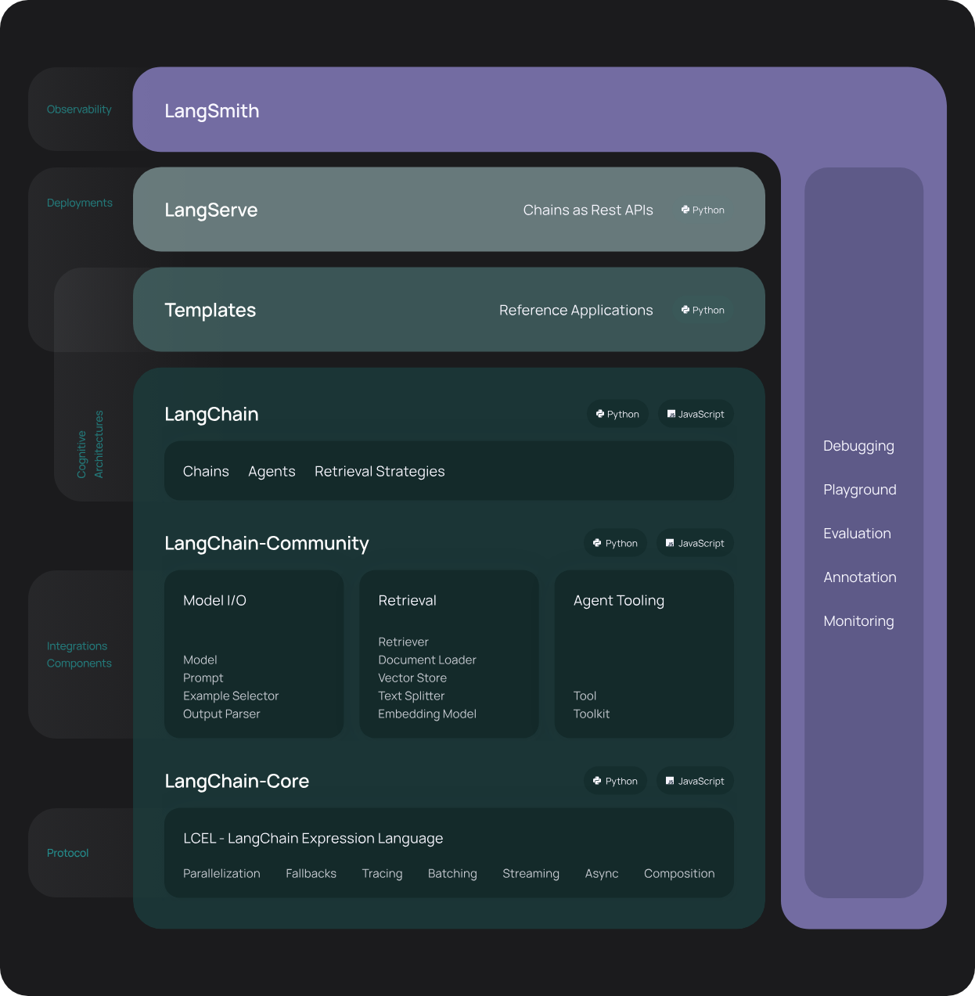

*Fig. 9; Langchain Architecture*

The architecture of Langchain is structured into several layers and components, each fulfilling distinct technical roles to enable its functionality and capability. This architecture can be dissected into three primary layers: the LLM layer, the Langchain layer, and the Application layer.

##### LLM Layer

Found at the foundational level, the LLM layer serves as the fundamental engine for language processing and generation. LLMs such as OpenAI, Hugging Face, and Flan are deployed within this layer, leveraging DL techniques and extensive training on large text corpora. Additionally, diverse LLM frameworks, including GPT-3 and LLAMA2, provide the necessary interface and functionalities for interaction with LLMs.

The LLM layer assumes responsibility for generating coherent responses following provided prompts or queries. Moreover, it can execute an array of language tasks such as translation, summarization, and content creation with remarkable proficiency and adaptability.

##### Langchain Layer

Situated above the LLM layer, the Langchain layer acts as the core framework for developing and deploying LLM-powered applications. It comprises various components and tools, including components, chains, agents, memory, and indexes. This layer empowers developers and data scientists to seamlessly construct, evaluate, and monitor LLM-driven applications such as DataworksAI chatbots, intelligent search engines, question-answering systems, summarization services, and robotic process automation agents.

The Langchain layer is responsible for streamlining the development and deployment lifecycle of LLM-powered applications by offering modularity, integration, and innovation features.

##### Application Layer

At the apex of the architecture, the application layer provides the primary platform for user interaction and utilization of LLM-powered applications. This layer encompasses various applications and services such as LangServe, LangSmith, and LangChain Templates, facilitating user access and utilizing LLM-powered applications across diverse devices and platforms.

The application layer is tasked with refining the interaction and consumption process of LLM-powered applications. It offers features and functionalities encompassing performance optimization, security enhancement, and usability improvements.

##### Langsmith

LangSmith offers a comprehensive platform for debugging, testing, evaluating, and monitoring Langchain applications. It provides developers and data scientists with valuable feedback and insights regarding LLM performance and application quality and supports various LLM frameworks for optimal selection.

##### Prompt Templates

LangChain templates encompass a collection of pre-made reference architectures catering to various LLM applications, including DataworksAI chatbots, intelligent search engines, question-answering systems, and summarization services. These templates serve as a valuable starting point for developers and data scientists, streamlining the development process while exemplifying best practices in LLM and Langchain utilization, such as prompt design, data retrieval, and chain optimization.

##### LCEL

LangChain Expression Language (LCEL) is a declarative method for composing chains seamlessly, enabling easy transition from prototype to production without code modifications. It supports many chain complexities, from basic prompt-LLM setups to intricate chains with hundreds of steps.

#### LlamaIndex Architecture

A framework for context augmentation in LLM-based applications. LlamaIndex is a robust data framework tailored for applications leveraging LLMs and seeking context augmentation. This framework facilitates the integration of context augmentation techniques into LLM systems, often called RAG systems. The primary objective of LlamaIndex is to provide essential abstractions that streamline the ingestion, structuring, and access of private or domain-specific data, enabling seamless integration into LLMs for enhanced text generation accuracy. Available in Python and Typescript, LlamaIndex offers versatile capabilities for ingesting diverse data sources and formats, ranging from APIs to SQL databases and beyond.

LlamaIndex system architecture revolves around a QueryPipeline abstraction, facilitating the orchestration of data workflows through declarative queries. Fundamental techniques and patterns include the provision of a declarative query API using which users can define their data processing tasks and transformations using a high-level, expressive syntax provided by the API. This simplifies the task of creating and managing complex data workflows, utilization of the QueryPipeline abstraction to connect various modules in a sequential or DAG manner, emphasis on modularity to enable independent development and seamless integration of modules, enhancement of code expressiveness and readability, integration with low-code/no-code solutions for improved productivity, the anticipation of future scalability and portability needs through considerations like serializability, and provision of a cookbook containing practical examples and guidance for users to leverage the QueryPipeline interface effectively.

Key Features of LlamaIndex for Context Augmentation

LlamaIndex presents a comprehensive suite of tools designed to expedite the development of production-ready RAG systems:

1. Data Connectors: These connectors facilitate the ingestion of data from diverse native sources and formats, including APIs, PDFs, SQL databases, and more.
2. Data Indexes: LlamaIndex structures ingested data into intermediate representations optimized for efficient consumption by LLMs.
3. Engines: LlamaIndex offers engines that provide natural language access to enriched data contexts. These include query engines for knowledge-augmented output retrieval, chat engines for interactive conversational interactions, and Data agents, which are LLM-powered knowledge workers augmented with additional tools and integrations.
4. Application Integrations: LlamaIndex seamlessly integrates with various applications, including LangChain, Flask, Docker, ChatGPT, and others, enabling seamless incorporation into existing ecosystems.

## 

## [**LangChain**](https://python.langchain.com/docs/get_started/quickstart) **vs**[LlamaIndex](https://github.com/run-llama/llama_index)**:**

| Features | LLamaIndex | LangChain |
| --- | --- | --- |
| Primary Focus | Intelligent search and data indexing and retrieval | Building a wide range of Gen AI applications |
| Data Handling | Ingesting, structuring, and accessing private or domain-specific data | Loading, processing, and indexing data for various uses |
| Customization | Offers tools for integrating private data into LLMs | Highly customizable, allowing users to chain multiple tools and components |
| Flexibility | Specialized for efficient and fast search | General-purpose framework with greater flexibility in application behavior |
| Supported LLMs | Connects to any LLM provider like OpenAI, and HuggingFace | Supports over 60 LLMs, including popular frameworks such as OpenAI, HuggingFace, and AI21 |
| Use Cases | Best for applications that require quick data lookup and retrieval | Suitable for applications requiring complex interactions like DataworksAI chatbots, and summarization |
| Integration | Functions as a smart storage mechanism | Designed to bring multiple tools together and chain operations |
| Programming Languages | Python based library | Python based library |
| Front-end libraries | LlamaIndex.ts | LangChain.js |
| Application breadth | Focused on search-centric applications | Supports a broad range of applications |
| Deployment | Ideal for proprietary or specialized data | Facilitates the deployment of bespoke NLP applications |

*Table 3. Comparison of LangChain and LlamaIndex framework based on different features*

In each framework, distinctions are apparent not only in technical capabilities but also in customization and application breadth. LlamaIndex serves as a plug-and-play solution primarily tailored for search-centric applications. Conversely, LangChain lays the foundation for a broader spectrum of applications, albeit requiring more profound customization, thereby affording developers greater flexibility. When projects demand tailored solutions or integration of diverse functionalities beyond basic data retrieval, LangChain may be preferable. The choice between LlamaIndex and LangChain depends on project requirements; LlamaIndex suits data-intensive projects needing rapid access to specific information, while LangChain caters to experimental projects requiring integration of various LLM capabilities and additional APIs or tools

### 

### **3.1 Implementation with Lang**C**hain:**

**Implementation**

Developing a natural language to SQL model via LangChain entails a systematic implementation process. A foundational model is initially constructed using the `create_sql_query_chain` method, serving as the basis for subsequent improvements.

**SQL Query Chain**

The `create_sql_query_chain` method within LangChain constructs a chain for generating SQL queries in response to user inquiries. It takes inputs from a language model (`llm`) for interpreting user queries, a SQL database (`db`) for query generation, and a prompt template (`final prompt`) for guiding the query generation process. The parameter `k` determines the number of results per select statement to return. The function outputs a chain that produces a corresponding SQL query when activated with a question. This functionality facilitates seamless integration of natural language queries with SQL database interactions, streamlining data retrieval and interaction efficiency.

**Incorporating a Few Shot Examples with Templates and Custom Example Selector**

After establishing the primary chain, accuracy is enhanced by integrating few-shot learning techniques. The model is furnished with a small, carefully selected set of examples, which enhances its ability to comprehend and generate precise SQL queries. These examples encompass various query types and complexities, enabling the model to address a broader range of user queries effectively.

The few-shot prompt technique dynamically selects examples based on input, formatting them into a final prompt for the model's use. Embeddings, generated using OpenAI models and stored with FAISS and Chroma vector stores, facilitate this process. This chat prompt template supports few-shot examples, offering a versatile approach to generating responses.

The structure produced by this template consists of a list of messages: prefix message(s), example message(s), and suffix message(s). This arrangement allows for the creation of conversations with intermediate examples, enhancing the model's contextual understanding. Additionally, the template can generate a fixed list of examples or dynamically select them based on input.

Two essential techniques are employed: example_selector and example_prompt. The example_selector is responsible for selecting few-shot examples, ordered based on relevance. A common implementation is the vectorstore-backed SemanticSimilarityExampleSelector. Meanwhile, the example_prompt converts each example into one or more messages, typically including a human message and an AI response, or a human message followed by a function call message.

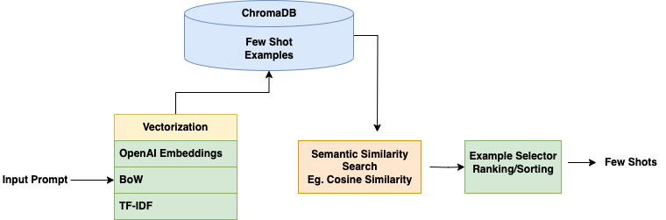

*Fig. 10; Dynamic Data Retrieval using Few Shot Examples*

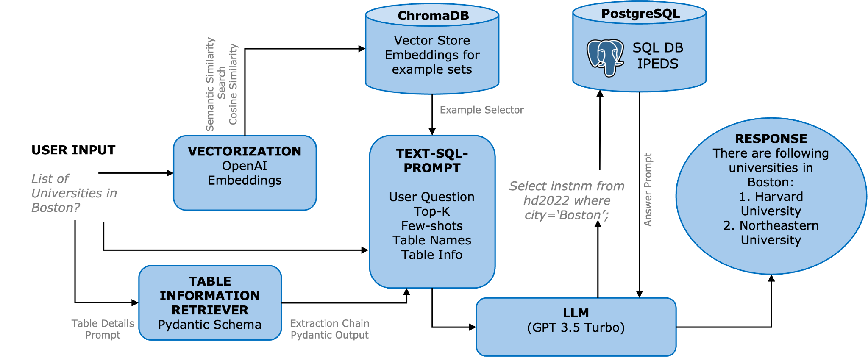

*Fig. 11; Dynamic Table Retrieval with `create_extraction_chain_pydantic` Method*

Additionally, dynamic table selection is implemented to focus the model's attention solely on tables relevant to the user's query. The `create_extraction_chain_pydantic` method accepts inputs including a Pydantic base model, table names and descriptions, and a prompt for guiding table retrieval. This information is fed into the `table_names_to_use` function within our created SQL query chain. This approach reduces the information scope the model must consider, leading to improved performance, accuracy, and cost efficiency. Through leveraging smaller, focused prompts, the model's precision in generating SQL queries is enhanced, thereby improving the user experience.

**Memory-Enhanced DataworksAI chatbots**

Furthermore, the DataworksAI chatbot is augmented with memory capabilities to intelligently handle follow-up questions related to the parent question. By retaining context from previous interactions, DataworksAI chatbots can generate more accurate and relevant SQL queries for follow-up questions, providing users with a seamless conversational experience.

Implementing message history recording involves creating a ChatMessageHistory object to store user queries and DataworksAI chatbot responses. This mechanism enables access to past interactions, enhancing contextual understanding. By integrating message history into prompt generation, the DataworksAI chatbot considers previous conversations when formulating responses. For instance, in Python, this can be realized through the ChatMessageHistory class provided by langchain.memory library. Leveraging previous interactions facilitates more informed and contextually appropriate DataworksAI chatbot responses, ultimately enhancing user experience and conversational quality

**Retrieval-Augmented Generation (RAG) Pipeline**

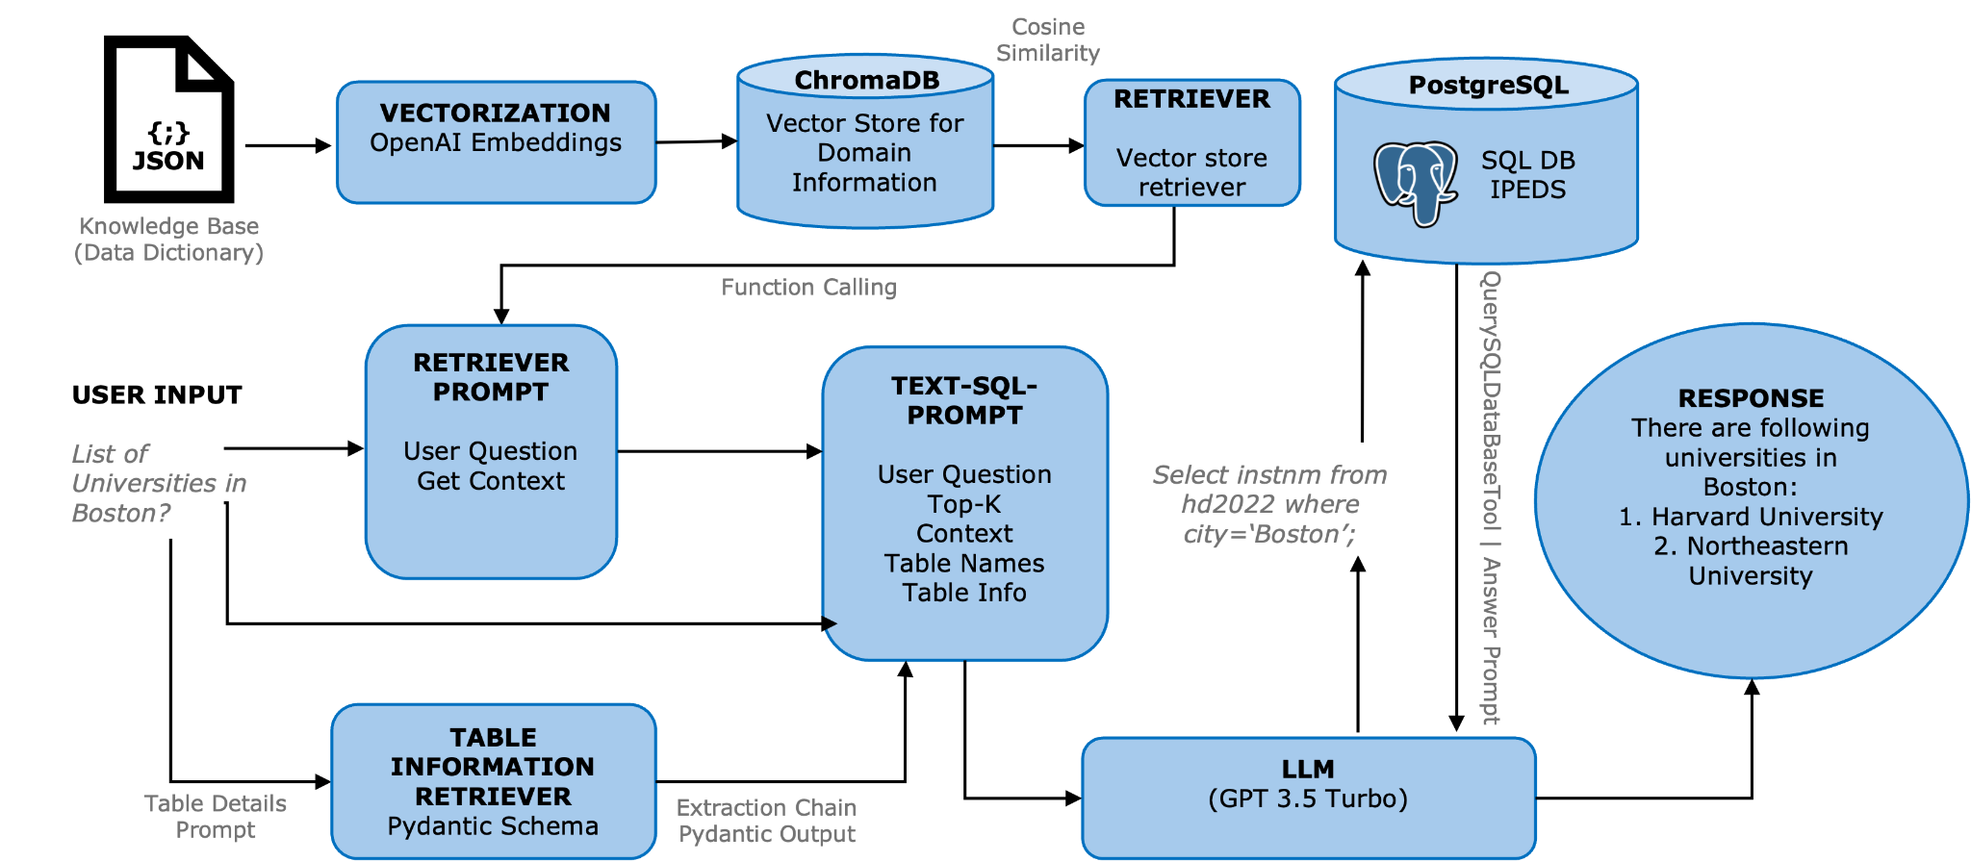

*Fig. 12; RAG Implementation with Langchain*

Finally, we chose the RAG approach instead of fine-tuning with a few shot prompt technique. We needed our LLM model to base its responses on large amounts of contextual data. This ensured robust responses and a RAG pipeline was implemented within LangChain following a systematic approach encompassing several vital steps.

The process begins with data retrieval, initiating interaction with the SQL database through LangChain to extract pertinent information based on user queries. This interaction enhances data extraction efficiency and caters to the specific requirements articulated in the user's query.

Following retrieval, the retrieved data dictionary is formatted into a suitable structure, such as JSON, for seamless integration with the LLM in subsequent processing stages. Structured data is then stored in Vector DB, facilitating the creation of a Vector Index for SQL tables and their columns. This optimizes data retrieval efficiency and compatibility with subsequent processing stages.

Compatibility with the LLM is ensured in further processing steps by augmenting the query with relevant information extracted from the database, refining the LLM's comprehension for accurate response generation. Response generation utilizes the augmented query to prompt the LLM to generate contextually relevant responses aligning with user expectations.

By leveraging the LLM's language generation capabilities, the system produces coherent and informative responses, culminating in a comprehensive user interaction experience. Overall, this architecture enables seamless integration of data retrieval, processing, and response generation stages, optimizing the effectiveness of the RAG model implementation within the LangChain framework.

### **3.2** Implementationwith **L**l**amaIndex**

1. Query Pipeline for Agentic Workflow with Retry Prompt

The modules include:

1. Input Component
2. Retry Prompt
3. Out of the shelf SQL Query Engine (NLSQLTableQueryEngine)
4. Query Validation Prompt
5. LLM

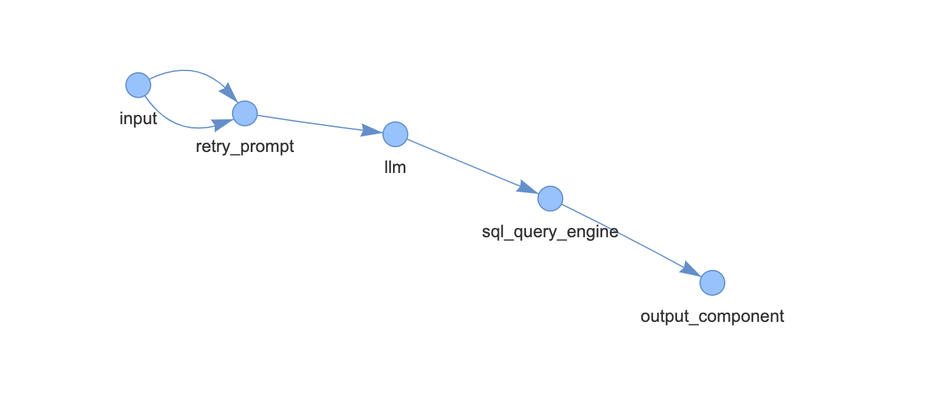

*Fig.13; DAG for Query Pipeline for Agentic Workflow with Retry Prompt*

In the implementation, a simplified retry agent pipeline specifically tailored for text-to-SQL conversion featuring integrated retry logic to enhance query resolution accuracy. This streamlined approach focuses solely on text-to-SQL functionality and incorporates retry capabilities. Core modules include an agent input component for initializing conversation history and user input processing, a retry prompt template for generating modified queries based on previous conversation history, and an output processor for validating query responses and managing retry iterations. The agent output function dynamically adjusts SQL queries based on feedback of earlier attempts, iteratively refining the query until a satisfactory response is obtained or the maximum iteration limit is reached. Network visualization tools clearly represent the pipeline architecture, facilitating system comprehension and management. Overall, this implementation offers a straightforward yet practical approach to improving text-to-SQL query resolution through iterative refinement and validation mechanisms, enhancing the accuracy and usability of the system.

1. Query Pipeline for Text-to-SQL with Query-time table retrieval and RAG

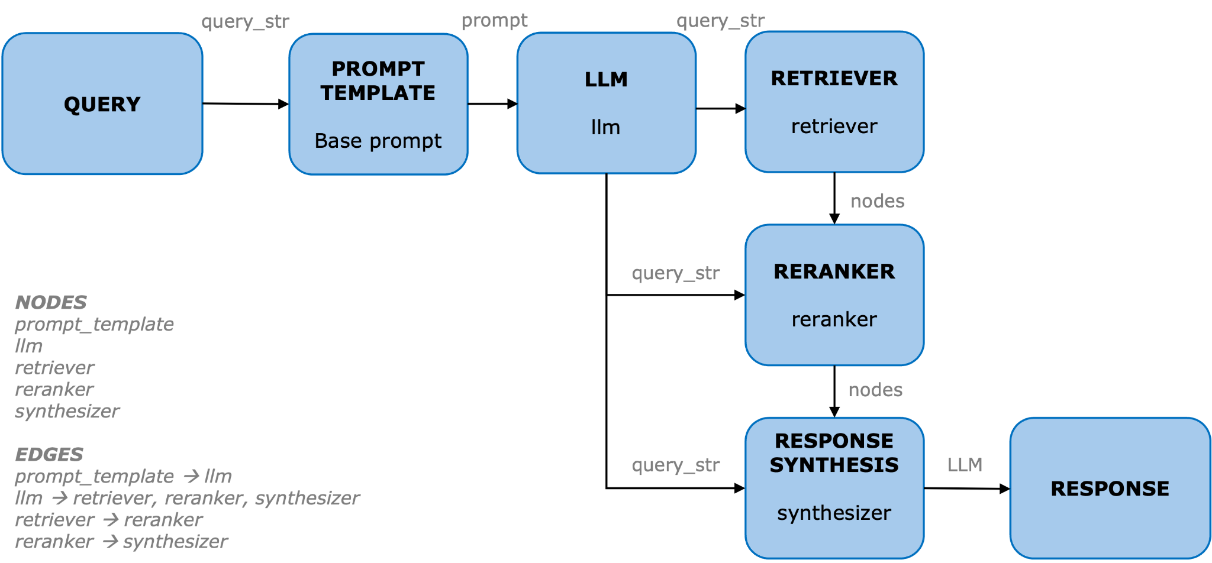

*Fig. 14; LlamaIndex Text-to-SQL Query Pipeline*

The core modules include:

1. ObjectIndex + Retriever (to store table schemas)
2. SQL database object to connect to the above tables + SQLRetriever.
3. Text-to-SQL Prompt
4. Response Synthesis Prompt
5. LLM

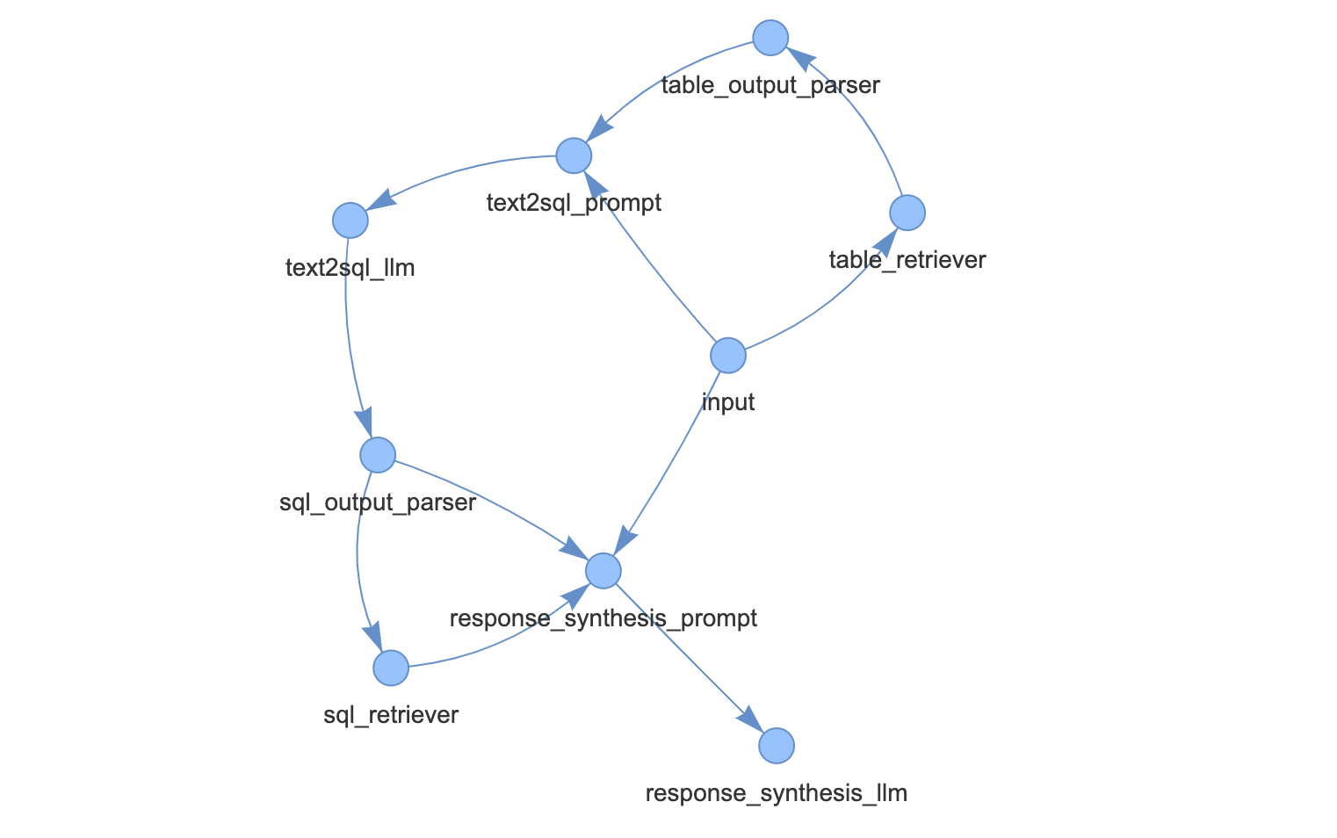

*Fig.15; DAG for Query Pipeline for Text-to-SQL with Query-time table retrieval and RAG*

A comprehensive text-to-SQL pipeline, enriching its capabilities through advanced techniques such as query-time table retrieval and response synthesis. The pipeline architecture, defined by core modules including indexing of objects, SQL database connectivity, and Large Language Models (LLMs), facilitates efficient processing of user queries. Through meticulous configuration of components such as the SQLRetriever, Text-to-SQL Prompt, and Response Synthesis Prompt, we have enabled seamless conversion of natural language input into SQL queries, retrieval of relevant tables, and synthesis of coherent responses based on query results. The systematic definition and visualization of the query pipeline using network visualization tools have facilitated clear understanding and management of the system architecture. Overall, the implementation exemplifies a robust and adaptable approach to text-to-SQL processing, offering enhanced efficiency and usability for a wide range of applications in data manipulation and analysis.

### 

#### *SQL Database Integration:* The code integrates with a SQL database using SQLAlchemy to perform SQL queries and retrieve data from the database.

* The IPEDS dataset likely contains a vast amount of structured data stored in SQL tables. By integrating with a SQL database using SQLAlchemy, this can efficiently query this data based on user requests. For example, users might ask for information about universities, enrollment statistics, or graduation rates, which can all be retrieved from the database using SQL queries.

#### *Vector Store Indexing:* It utilizes Vector Store Indexing to index and retrieve vector representations of objects stored in the database, enabling efficient similarity searches.

* In the context of the IPEDS dataset, this technique is applied to efficiently search for similar universities or institutions based on certain criteria such as enrollment demographics or program offerings. For instance, users could query for universities like a given institution in terms of student demographics or academic programs.

#### *Streamlit UI:* The code utilizes Streamlit, a Python library, to create a user-friendly web-based interface for interacting with the DataworksAI chatbot and querying the database.

* As mentioned above Streamlit UI provides a user-friendly interface for users to interact with the DataworksAI chatbot and query the IPEDS dataset. Users can input their questions or requests through the Streamlit interface, and the DataworksAI chatbot will provide responses based on the queried data. This interface makes it easy for users to explore and analyze the dataset without needing to write complex SQL queries themselves.

#### *OpenAI GPT-3.5 Language Model:* It leverages the OpenAI GPT-3.5 language model to generate responses to user queries based on the provided prompts and the context of the conversation.

* In the IPEDS dataset project, the language model is used to understand and interpret user queries, generate SQL queries based on the user's intent, and provide informative responses tailored to the user's needs. For example, users could ask questions about graduation rates or financial aid distribution, and the language model would generate relevant SQL queries to retrieve the requested information from the dataset.

#### *Prompt-based Query Pipeline:* The code implements a query pipeline using prompts, where user queries are transformed into SQL queries using templates, then passed to the language model for response synthesis.

* In the IPEDS dataset project, this pipeline enables users to ask questions in natural language, such as "What are the total number of universities located in Massachusetts?", and receive accurate responses based on the queried data. The pipeline handles the translation of user queries into SQL queries and generates informative responses that address the user's inquiries.

Missing Sections-Models

Chaining

Retriever

VectorDB:

Books for Diagrams and article links-

1. https://learning.oreilly.com/library/view/hands-on-large-language/9781098150952/

Hosting:

This project also explores deploying a newly developed DataworksAI chatbot application on a [Mass Open Cloud (MOC)](https://massopen.cloud/nerc-tutorial/) platform. MOC, with its open-source foundation and ability to handle large user bases, offers a unique environment for DataworksAI chatbot hosting. We aim to investigate the feasibility and potential benefits of leveraging an MOC platform for our DataworksAI chatbot, designed for statistics on postsecondary education in the US. It's important to note that alternative platforms like [Hugging Face](https://huggingface.co/) and [Streamlit Cloud](https://streamlit.io/cloud) are also emerging as strong contenders for DataworksAI chatbot deployment, offering user-friendly interfaces and functionalities tailored for machine learning applications. This project will also contribute to the growing discussion on selecting the most suitable platform for deploying DataworksAI chatbot applications.

## Results and Discussion

LlamaIndex

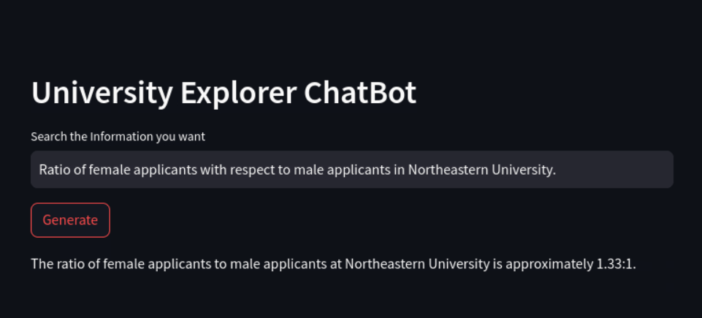

*Fig.16; Query 1*

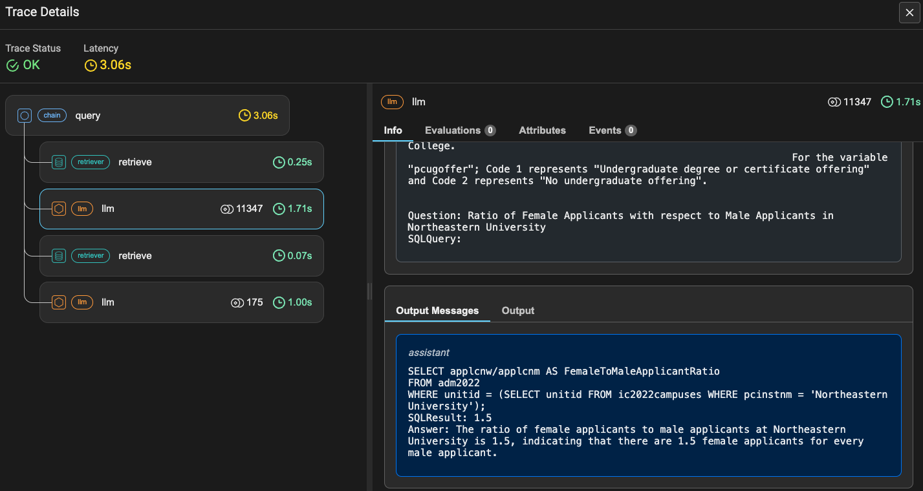

*Fig. 17; SQL Query 1*

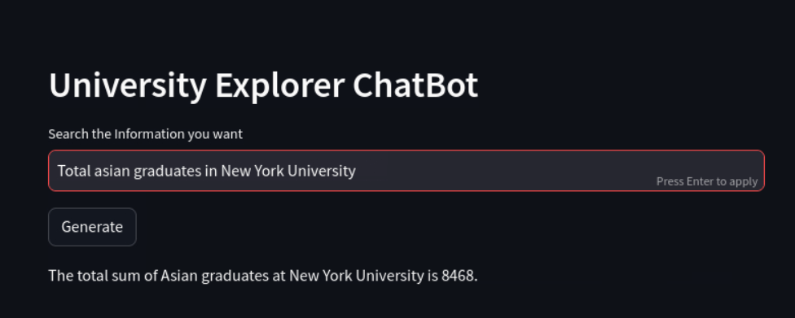

*Fig. 18; Query 2*

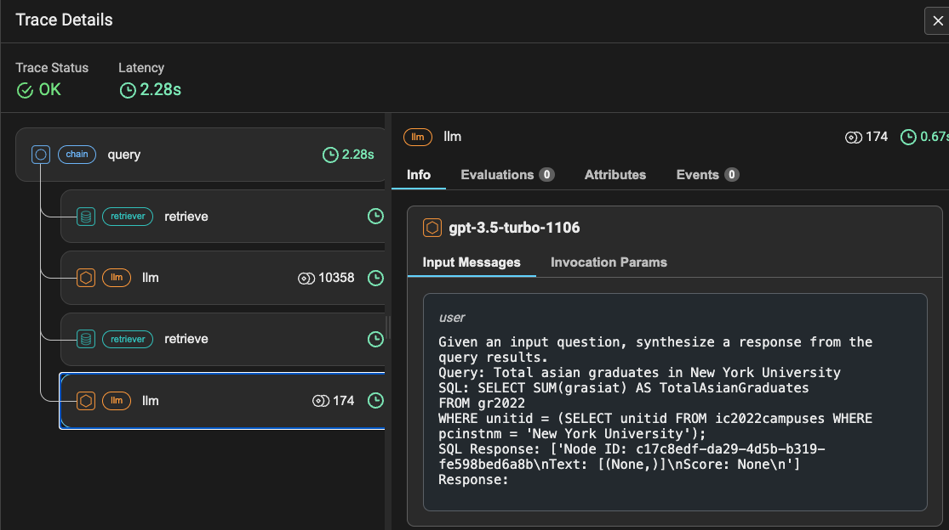

*Fig.19; SQL Query 2*

Langchain

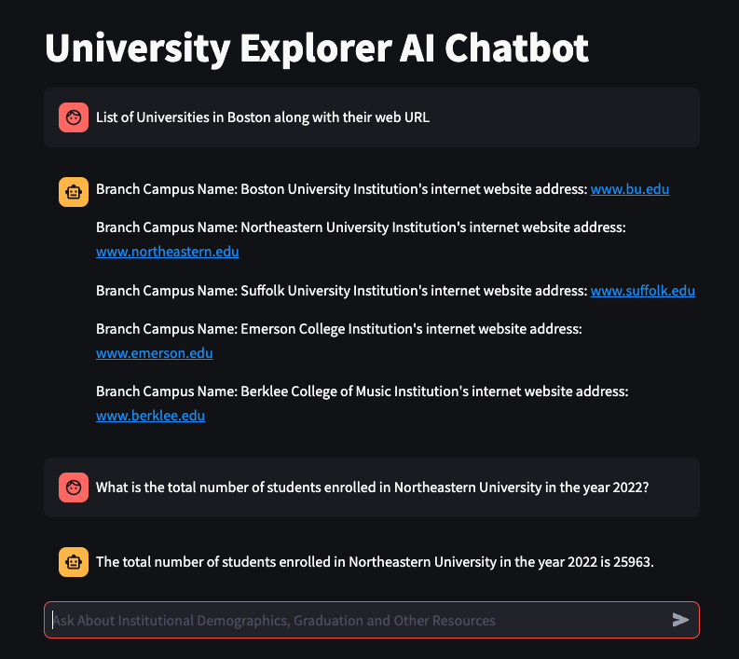

*Fig.20; Query 1*

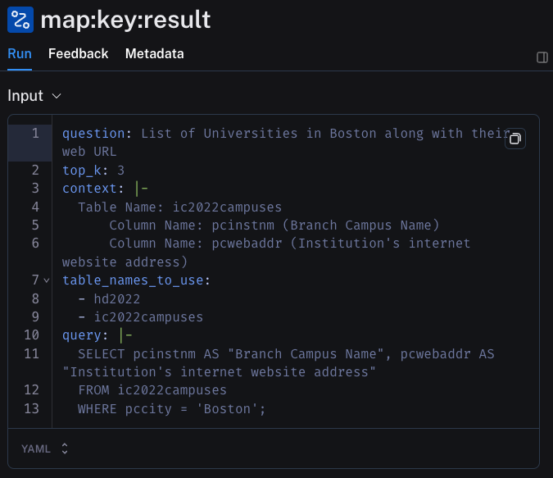

*Fig.21; SQL Query 1*

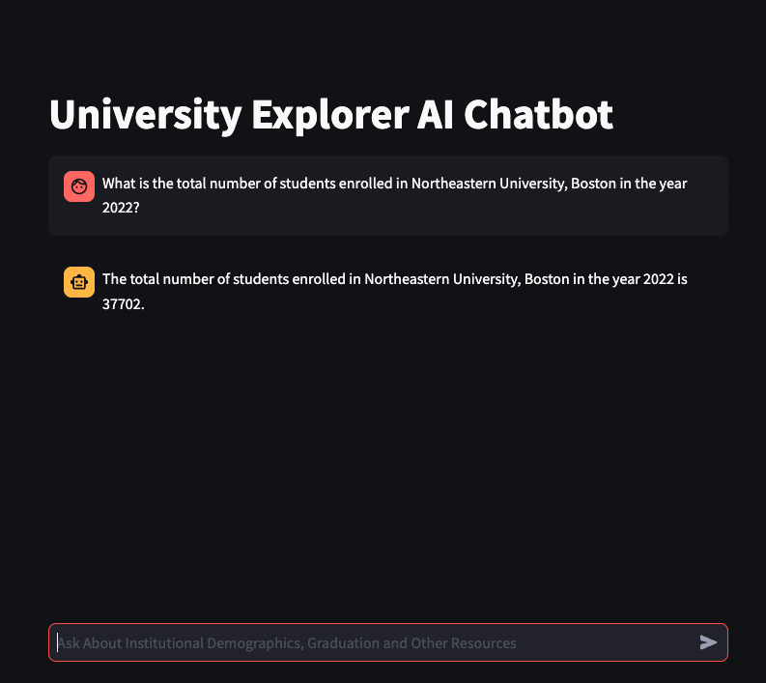

*Fig.22; Query 2*

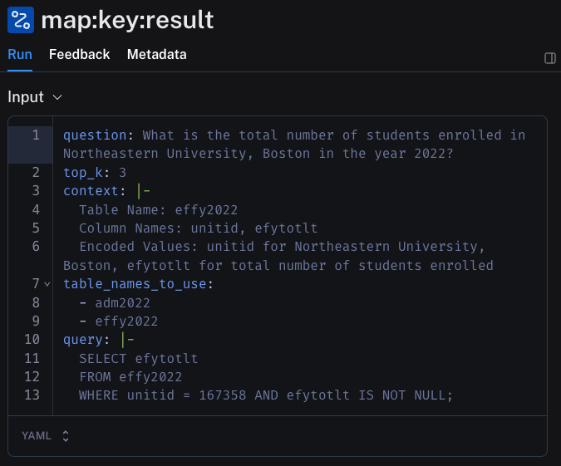

*Fig.23; SQL Query 2*

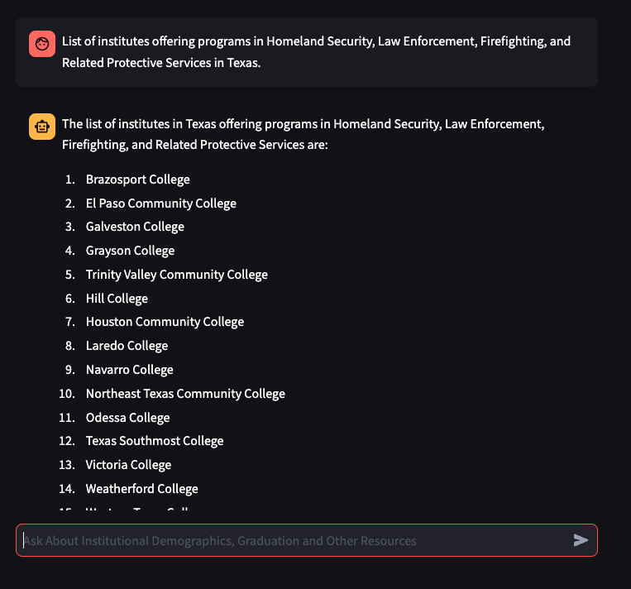

*Fig.24; Query 3*

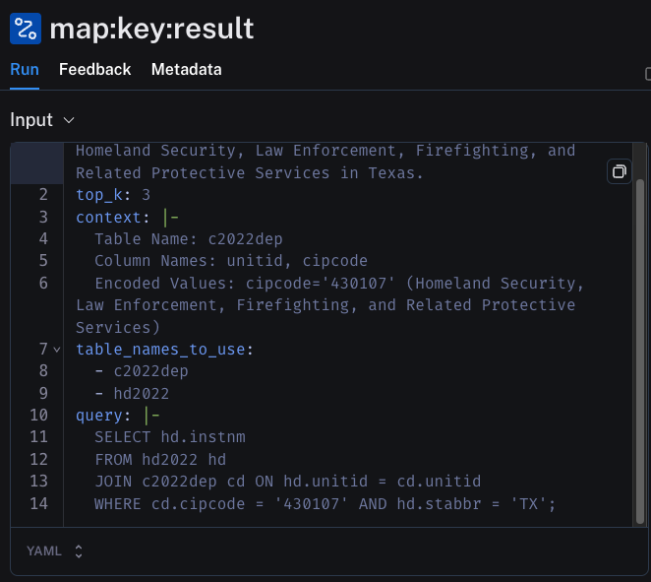

*Fig.25; SQL Query 3*

*HS>> SQL queries*

## Evaluation and Testing

SQL queries were written to facilitate DataworksAI chatbot testing by providing a reference point for verifying the accuracy of its responses. By executing these queries, testers can compare the results obtained from the DataworksAI chatbot with the data retrieved directly from the database. This ensures that the DataworksAI chatbot's responses align with the expected outcomes based on the underlying data. Additionally, SQL queries serve as a means of validating the functionality and performance of the DataworksAI chatbot, enabling testers to identify any discrepancies or inconsistencies in its behavior. Ultimately, integrating SQL queries into the testing process enhances the reliability and effectiveness of the DataworksAI chatbot by ensuring that it delivers accurate and relevant responses to user queries.

## Modeling Quadrant

The Modeling quadrant is one of the fundamental cornerstones of this project. Advanced analytics engineers create models by learning, identifying patterns, and synthesizing data to represent real-world systems. The analytics model represented by the real-world systems can take various forms. In this case, the data taken from the IPDES survey website is utilized to develop the text-SQL DataworksAI chatbot and NLP tasks are performed where the natural language is translated into a SQL query to generate prompt-based responses. In this way the analytics model can reduce the uncertainties and increase the dependability. There are three crucial factors in the modeling quadrant, they are:

* Develop advanced analytics model
* Validate and Verify
* Iterate and Repeat

**Develop Advanced Analytics Model**

According to Prof. Hema in "Analytics for Business Success," creating sophisticated analytics models is a difficult and resource-intensive process that calls for the integration of complicated business logic into algorithms that can identify patterns, organize data, and transform it into organized representations.

In order to expedite model creation, this study presents the pretrained GPT-Turbo-3.5 LangChain and LlamaIndex framework integration. With the help of its Language Chain Expression Language (LCEL), LangChain makes it easier to create customized chains that include preprocessing and command sequences. These chains are built with LCEL and include many processing modes along with monitoring capabilities to guarantee flexibility and effectiveness in model execution. Furthermore, LangChain uses dynamic few-shot prompting techniques to improve DataworksAI chatbot performance for precise response creation, especially for jobs including university recommendation.

LlamaIndex's design provides a strong basis for storing and retrieving structured data, especially table schemas that are essential for text-to-SQL operations. Its ObjectIndex component provides fast retrieval of schema information by providing a flexible indexing technique for storing different Python objects. LlamaIndex expedites data retrieval and manipulation inside the system when combined with features like the SQLRetriever, which effectively searches the database to obtain relevant data in answer to queries. Additionally, functions like the Query Validation Prompt and Retry Prompt guarantee the accuracy and dependability of query replies, improving the text-to-SQL framework's overall efficiency.

**Validation and Verification**

In the realm of advanced analytics models, meticulous verification and validation procedures are imperative to ensure their accuracy and reliability. Verification encompasses confirming the model's adherence to prescribed specifications and operational requirements, necessitating comprehensive testing across diverse scenarios to evaluate its data processing capabilities and predictive accuracy. Conversely, validation focuses on assessing the model's efficacy in achieving its intended objectives by scrutinizing its performance against real-world data and expert assessments. In our specific context, the developed DataworksAI chatbot undergoes rigorous testing against various inquiries to validate its responses, with LangSmith serving as a tool to monitor and verify the corresponding SQL queries generated in response to each query, it further assists in debugging the code. This approach ensures the DataworksAI chatbot's reliability and effectiveness in delivering accurate responses to user inquiries, as illustrated by the accompanying figures demonstrating the DataworksAI chatbot's response to a specific question and the corresponding SQL query generated.

**Iterate and Repeat**  
The continual improvement of the DataworksAI chatbot's functionality and efficiency is emphasized by the "Loops, not Lines" philosophy. The capacity of the DataworksAI chatbot to correctly read user questions and produce SQL replies is continuously improved by developers through iterative cycles of testing, feedback assimilation, and model modification. Through this iterative process, developers may improve question generation algorithms, enhance the DataworksAI chatbot's natural language comprehension skills, and fix any errors or inconsistencies in the DataworksAI chatbot's replies. Through the use of an iterative development approach, developers may enhance the DataworksAI chatbot's functionality over time, guaranteeing its efficacy and dependability in aiding users with SQL query chores.

### 

### Software Engineering Quadrant

The prototype created in the modeling quadrant of the Analytics Product Life Cycle (APLC) is put into action, deployed, and automated in the software engineering quadrant. With the help of Mass Open Cloud (MOC) platform where the DataworksAI chatbot is set be hosted, using streamlit the Text-to-SQL DataworksAI chatbot is rigorously tested and refined to enable a smooth integration into current organizational procedures. Furthermore, LangSmith is incorporated as a monitoring tool, to continually analyze the DataworksAI chatbot's performance and validity of findings.

After the DataworksAI chatbot is first programmed and validated, it is critical to set up an automated monitoring system to maintain the consistency and quality of its outputs over time. This calls for continuous verification of underlying presumptions, retesting of hypotheses, and integration of updated tactics and fresh information, such as behavioral insights from customers. In order to build user confidence and encourage adoption of the analytics system, an automated monitoring and alerting system is necessary to quickly identify any unusual activity or inaccurate data.

## Deployment and Hosting

## Limitations

The LangChain and LlamaIndex frameworks' large language models have some restrictions resulting from computational limits and implementation complexities. In particular, the RAG pipeline's resource-intensive design and GPU compute power present difficulties since they need a large number of tokens, frequently surpassing the capacity of systems. Furthermore, data quality is critical since it affects model training effectiveness and backend SQL query generation precision. Interestingly, the way the model is implemented now is only designed to handle structured data; unstructured data will need to be adapted in the future.

These constraints highlight the need for reliable solutions to go beyond issues with data quality and computing limits. Optimization approaches to improve GPU usage and reduce token limitations, as well as data pretreatment techniques to guarantee data cleanliness and enable precise model training, are some examples of suggested methodologies. Furthermore, new developments in algorithmic design and model architecture might make it possible to incorporate unstructured data processing capabilities into current frameworks, expanding their range of applications. The LangChain and LlamaIndex frameworks are ready to develop further as research goes on, providing improved performance and flexibility to satisfy the expanding needs of many application scenarios in the field of information retrieval and natural language processing.

## **Conclusion**

## **Future Scope**

* In future work, incorporating the [RAG (Retrieval-Augmented Generation)](https://pub.towardsai.net/advanced-rag-techniques-an-illustrated-overview-04d193d8fec6) approach, combining search algorithms with LLM prompting, could enhance response accuracy and context relevance by leveraging both query and retrieved context in the prompt sent to the LLM.

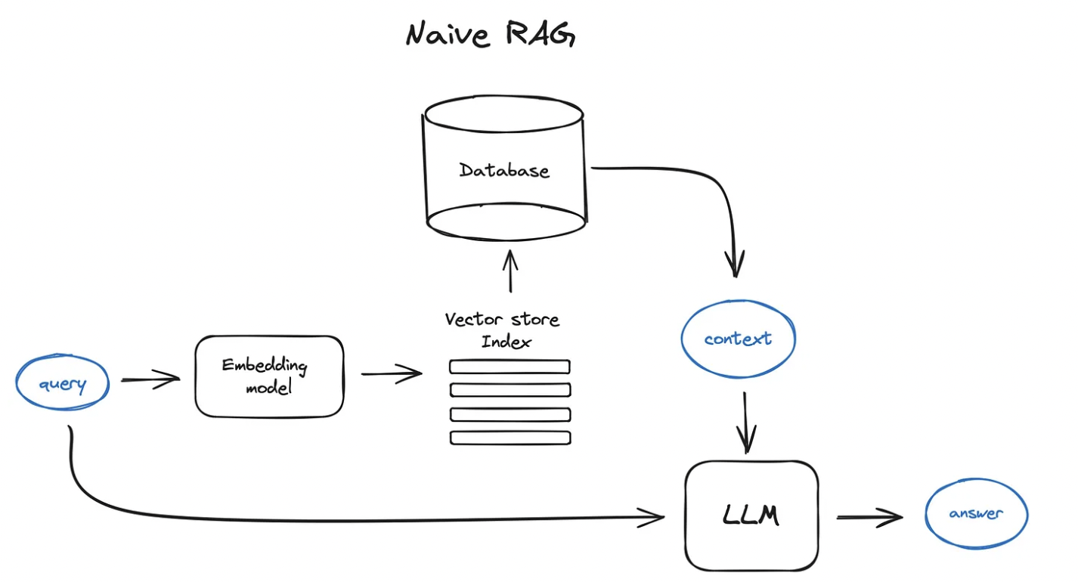

*Fig. 26; Naive RAG (Retrieval-Augmented Generation)*

* Consolidating data into a local database environment and initially limiting operations to a select few tables can streamline the standardization and cleanup process, enhancing dataset quality and facilitating smoother model training.
* Additionally implementing [Vector DB](https://www.elastic.co/what-is/vector-database) with hashing techniques will optimize storage and retrieval of data representations, enhancing scalability and performance.

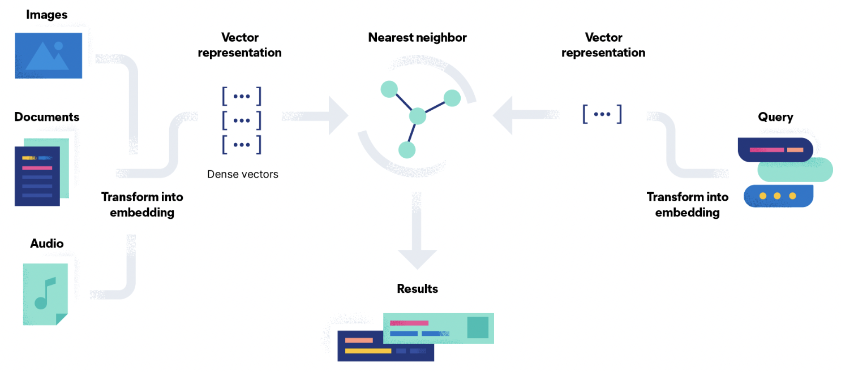

*Fig. 27; Naive RAG (Retrieval-Augmented Generation)-VectorDB*

* Moreover, optimizing computational resources by leveraging cloud-based GPU resources from platforms like Google Cloud Platform (GCP) or Amazon Web Services (AWS) would facilitate smoother training and deployment processes.

## 

# Glossary

*BERT*: Bidirectional Encoder Representations from Transformers(BERT), is a deep learning model that builds upon the [transformer architecture](https://en.wikipedia.org/wiki/Transformer_(deep_learning_architecture)) introduced in the groundbreaking paper "[Attention is All You Need](https://research.google/pubs/attention-is-all-you-need/)." It employs a unique approach where each output element engages with every input element, and their weightings are dynamically calculated.

[*Chroma vector stores*](https://blog.langchain.dev/langchain-chroma/#:~:text=Chroma%20is%20a%20vector%20store,machine%20%2D%20just%20pip%20install%20chromadb%20!): Chroma DB is an open-source vector store and embeddings database tailored for efficient storage and retrieval of vector embeddings, facilitating the development of AI applications.

*Codex*: Specifically trained to comprehend and produce code in a wide range of programming languages, Codex is a sizable language model created by OpenAI that is useful for automating software development activities and offering developers assistance with code.

*Context Augmentation*: Context augmentation refers to adding more information or data to the input context in order to improve the model's comprehension and performance, which in turn produces outputs that are more accurate and contextually relevant.

*Data dictionary:* A data dictionary is an organized document that provides thorough details regarding tables, columns, data types, variable names, and statistics related to a database schema. It acts as an essential reference manual for comprehending the characteristics, organization, and significance of the recorded data.

*Declarative Query API*: A declarative query API makes interaction with applications easier by abstracting backend complexity, allowing users to change system state and conduct operations programmatically using uniform request forms, decreasing complexity, increasing user experience, and facilitating version control.

[*FAISS*](https://ai.meta.com/tools/faiss/): Facebook AI Similarity Search is a library designed for efficiently searching embeddings of multimedia documents to find those that are similar. It addresses the shortcomings of traditional query search engines, offering more scalable similarity search functions compared to hash-based searches.

[*Flan*](https://blog.research.google/2021/10/introducing-flan-more-generalizable.html): Flan was created by Google and is renowned for its effective design and high-performance skills in tasks involving the creation and processing of natural language. In order to provide amazing outcomes with less computing resources, it combines cutting-edge approaches like transferring knowledge to a small/light-weighted model from a large/complex model and sparse attention mechanisms.

Graph representation: Graph representations capture complex linkages and dependencies by organizing data into a network of interconnected nodes and edges. They are useful for tasks in Text-to-SQL systems such as knowledge graph generation and semantic parsing.

In-context learning: In-context learning allows models to adapt during inference by using contextually relevant examples, vital for tasks like text-to-SQL where it enhances performance by learning from similar queries.

[*LCEL*](https://python.langchain.com/docs/expression_language/): In order to enable the development of sophisticated natural language processing pipelines inside the LangChain framework, LangChain created the Language Chain Expression Language (LCEL), a specialized language intended to represent complicated linguistic patterns and transformations. For applications like sentiment analysis, text production, and translation, it helps users to effectively design and modify language structures.

*LLama2*: Llama 2, Meta's open-source large language model (LLM), comprises transformer-based autoregressive causal language models tailored for assistant-like chat applications and adaptable to various natural language generation tasks, with specialized fine-tuning for programming tasks.

[*LlamaIndex Query Pipeline*](https://docs.llamaindex.ai/en/latest/module_guides/querying/pipeline/): The LlamaIndex Query Pipeline is a system that facilitates the transformation of natural language queries into SQL format, along with response aggregation, to enhance the efficiency and usability of Text-to-SQL systems.

*LLM-powered Applications*: They use large language models to carry out sophisticated natural language processing tasks including sentiment analysis, summarization, translation, and text production.

[*LoRA*](https://arxiv.org/abs/2106.09685): Low Rank Adaptation (LoRA) is a strategy in LLM that adjusts latent representations to increase the model's capacity to grasp and retrieve relevant information from datasets, resulting in improved performance in tasks like question answering and information retrieval.

[*ObjectIndex*](https://docs.llamaindex.ai/en/stable/examples/objects/object_index/): The ObjectIndex class in Python serves as a versatile tool for indexing arbitrary objects, allowing for flexible organization and retrieval based on defined criteria. It can be used in various scenarios, such as indexing Tool objects or SQLTableSchema objects, facilitating efficient access and manipulation.

[*Prompt engineering*](https://www.promptingguide.ai/): Prompt engineering, an emerging field, focuses on crafting and refining prompts to maximize the effectiveness of language models across diverse applications and research areas. Proficiency in prompt engineering aids in gaining deeper insights into the capabilities and constraints of large language models (LLMs).

*PyTorch*: It’s an open-source deep learning framework, which is well-known for its adaptability and simplicity in the creation and training of neural network models.

[*QLoRA*](https://arxiv.org/abs/2305.14314): Quantized Low Rank Adaptation (QLoRA) is a technique used in large language models to adjust latent representations based on query-specific information using quantization, thereby improving the model's ability to understand and respond to user queries while maintaining parameter efficiency.

*Query augmentation*: Query augmentation involves enriching the user's original query with additional context obtained from the processed data, enhancing its relevance and specificity for the language model.

*Query Pipeline*: QueryPipeline is an architectural abstraction that orchestrates data workflows by connecting various modules in a sequential or Directed Acyclic Graph (DAG) manner, allowing for efficient data processing and transformation.

*Query Validation Prompt*: In LLM, a query validation prompt is a common input question that is used to evaluate the model's capacity to produce legitimate and correct SQL queries. Typically, it contains evaluation-specific context or restrictions.

*Response generation*: Response generation utilizes the augmented query to prompt the language model to generate contextually relevant responses, thereby facilitating accurate and informative interactions between users and the system.

*Response Synthesis Prompt*: A Response Synthesis Prompt is a structured input query that directs the model to produce precise and contextually appropriate SQL queries in response to instructions or commands in natural language, enabling effective interaction with a database architecture. It aids the model in comprehending the purpose of the user's query and producing relevant SQL replies within the given context.

[*Retrieval-Augmented Generation (RAG)*](https://aws.amazon.com/what-is/retrieval-augmented-generation/#:~:text=Augmented%20Generation%20requirements%3F-,What%20is%20Retrieval%2DAugmented%20Generation%3F,sources%20before%20generating%20a%20response.): Retrieval-Augmented Generation (RAG) combines retrieval-based techniques with generative models to provide contextually appropriate replies, optimizing LLM output by adding a knowledge base outside its training data. It makes use of structured data dictionaries to extract relevant portions, which improves the DataworksAI chatbot's comprehension and precise SQL query creation in the context of a database design.

*Retrieval and Academic Support*: Information Retrieval and Academic Support is a system utilizing Langchain, LlamaIndex, and advanced language models like OpenAI GPT-3.5 Turbo and LLama2 to provide swift and accurate responses to inquiries related to admissions, programs, course registration, financial aid, and campus amenities, reducing the need for manual searches and supporting academic-related queries.

*Retry Prompt*: It provides a standardized framework for producing prompts in conversational systems. It guarantees the smooth management of user interaction and error handling when incorporated into such systems, improving the LLM's overall performance and usability in conversational applications.

RoBERTa: This is an improved version of BERT for pretraining NLP models featuring adjusted hyperparameters and embeddings, resulting in enhanced performance.

*RunnablePassThrough*: The LangChain framework's RunnablePassThrough function acts as a simple pass-through operation, allowing data or information to be sent from input to output without being processed. This allows for smooth data transmission along the pipeline.

*Sequence-to-sequence*: For tasks like text summarization and machine translation, neural networks known as sequence-to-sequence are utilized, which are built to analyze input sequences and produce corresponding output sequences.

*SQLRetriever*: It extracts relevant portions from databases using natural language queries in order to improve the precision of SQL query creation in text-to-SQL systems.

*SQL Query chain*: It is a component that leverages large language models (LLMs) to translate natural language questions into SQL queries, process query results, and generate user-friendly summaries or explanations of the data.

*Supervised fine-tuning*: Supervised fine-tuning enhances pre-trained language models by training them on labeled examples of natural language inquiries paired with their corresponding SQL queries, improving their ability to generate accurate responses to similar inputs.

*TensorFlow*: It’s an open-source machine-learning framework which is extensively used to create and train different deep learning models.

*TEXT-to-SQL*: Text-to-SQL automatically converts natural language queries into SQL queries, enabling easier interaction between non-expert users and database systems.

# **Appendix A: Postgres Data Load**

HS> Can we also include the work that Chris did and the git Repo. Here the note from him

* *The database accessible at the DigitalOcean URL has the 2022 IPEDS data ingested as individual tables into the public schema. You can browse around if you want using any appropriate interface (PgAdmin, DBeaver, psql, ...). It is a direct data dump from IPEDS, so what you see there is exactly as it is specified by IPEDS.*

*Username:*

*Pwd:*

* *In the git repo I have placed a script that I wrote to parse the HTML fragment that we got from the IPEDS site containing the download URLs. And there is another script to run the actual download with those URLs.*
* *I did not put the downloaded CSV files into the git repo since they are large, but I did put the data dictionaries. The students will probably need to use those in some way to successfully query the database with an LLM.*
* *There is a script to ingest CSV files into the SQL database and there is another script to query the SQL database and return the results in a Pandas dataframe.*

The database accessible at the DigitalOcean URL contains the 2022 IPEDS data, organized into separate tables within the public schema. Users can explore the database using tools like PgAdmin, DBeaver, or Psql. The data is directly sourced from IPEDS, maintaining its original specifications.

**Data Load Scripts available in Github**:

To facilitate data access, a script is provided in the [git repository](https://github.com/hemadataworksai/ipedsllm/tree/main/scripts) to parse HTML fragments from the IPEDS website, extracting download URLs. Another script enables downloading using these URLs. Due to their large size, the CSV files are not included in the repository, but detailed data dictionaries are available to help users understand the dataset's attributes.

Additionally, scripts are available for ingesting CSV files into the SQL database and querying the database to retrieve results in a Pandas dataframe format. These resources streamline data manipulation and analysis for researchers and students. There are also multiple CREATE and INSERT statements in a [git folder](https://github.com/hemadataworksai/ipedsllm/tree/main/Data/SQL_Scripts) which can be used to create tables in a different db or schema.

Data can be loaded by creating tables and adding data into them after the dbeaver has been installed and connected to the database. There are two ways to load data in Dbeaver. Writing and executing the SQL script is one method. The steps for this are explained below.

1. Define a table:

Firstly we need to define a table and its attributes by using the ‘create’ statement. The example syntax for CREATE is given below.

**CREATE** **TABLE** ipedsdata.ic2022campuses (

unitid int4 **NULL**,

campusid int8 **NULL**,

pcinstnm **varchar**(128) **NULL**,

pcaddr **varchar**(50) **NULL**,

pccity **varchar**(50) **NULL**,

pcstabbr **varchar**(50) **NULL**,

pczip **varchar**(50) **NULL**,

pcfips int8 **NULL**,

pcobereg int8 **NULL**,

pcchfnm **varchar**(50) **NULL**,

pcchftitle **varchar**(50) **NULL**,

pcgentele int8 **NULL**,

Here we can define the schema name ‘ipedsdata’, table name which is ‘ic2022campuses’, column names such as ‘unitid’, ‘campusid’, ‘pcinstnm’ etc and then data type whether it is integer, varchar etc. After running this query a table would be created into which data can be inserted.

1. Insert Data into defined table:

In the table ‘ic2022campuses’, data can be inserted using a ‘INSERT’ sql statement which will have the table name, columns and their respective data in order. An example syntax for the statement is shown below.

**INSERT** **INTO** ipedsdata.ic2022campuses

(unitid,campusid,pcinstnm,pcaddr,pccity,pcstabbr,pczip,pcfips,pcobereg,pcchfnm) **VALUES**

**(102368,1,'Troy University-Phenix City**

**Campus','1510 Whitewater Avenue','Phenix**

**City','AL','36869-4419',1,5,'Dr0 Dionne**

**Rosser-Mims','Vice Chancellor' )**

After creating required tables and inserting all the data we can commit the changes and the data will be stored in the table for our use. In the same way we can load all the required tables.

An advantage of having tools such as Dbeaver is that they have many features or shortcuts to save time in tasks such as importing or exporting data from files. If we have the data downloaded in csv we can directly import data from the file. The detailed steps are explained below.

1. Right click on the ‘Tables’ as seen in fig and click on ‘import data’ to load data from csv’s

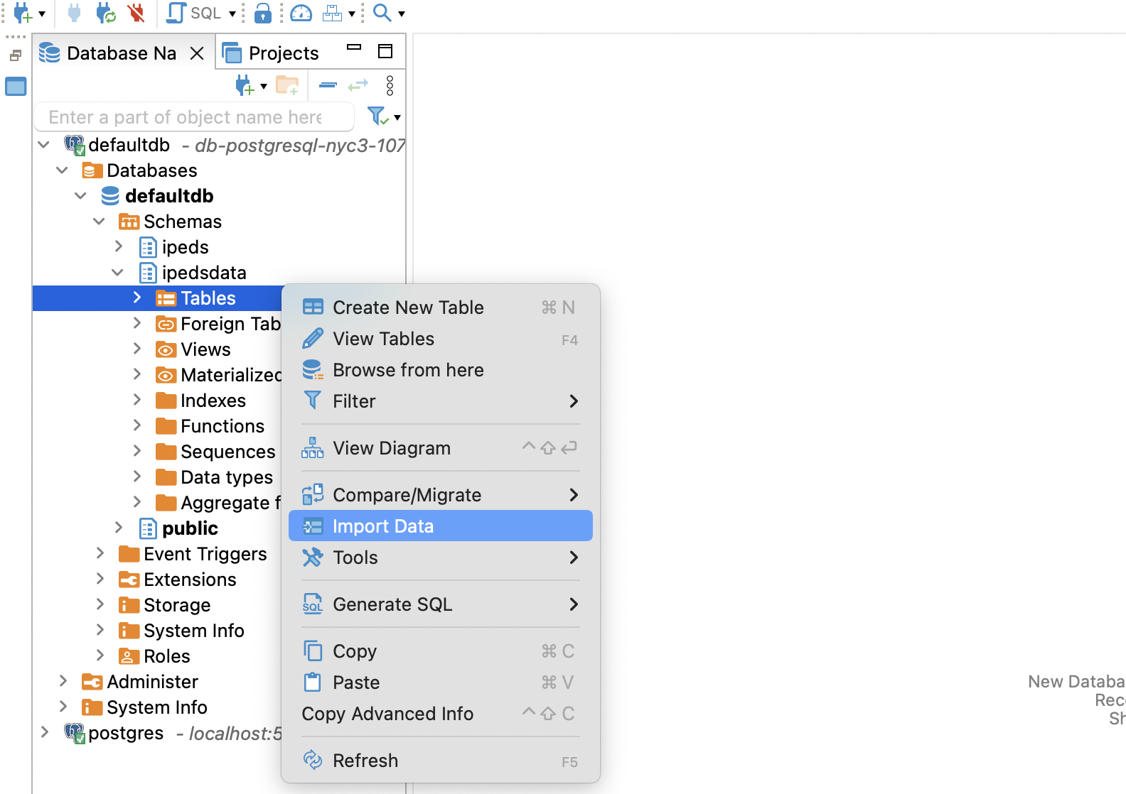

*Fig. 28; Importing Data*

1. You will get an option to select the source as seen below and select the respective file from the local system.

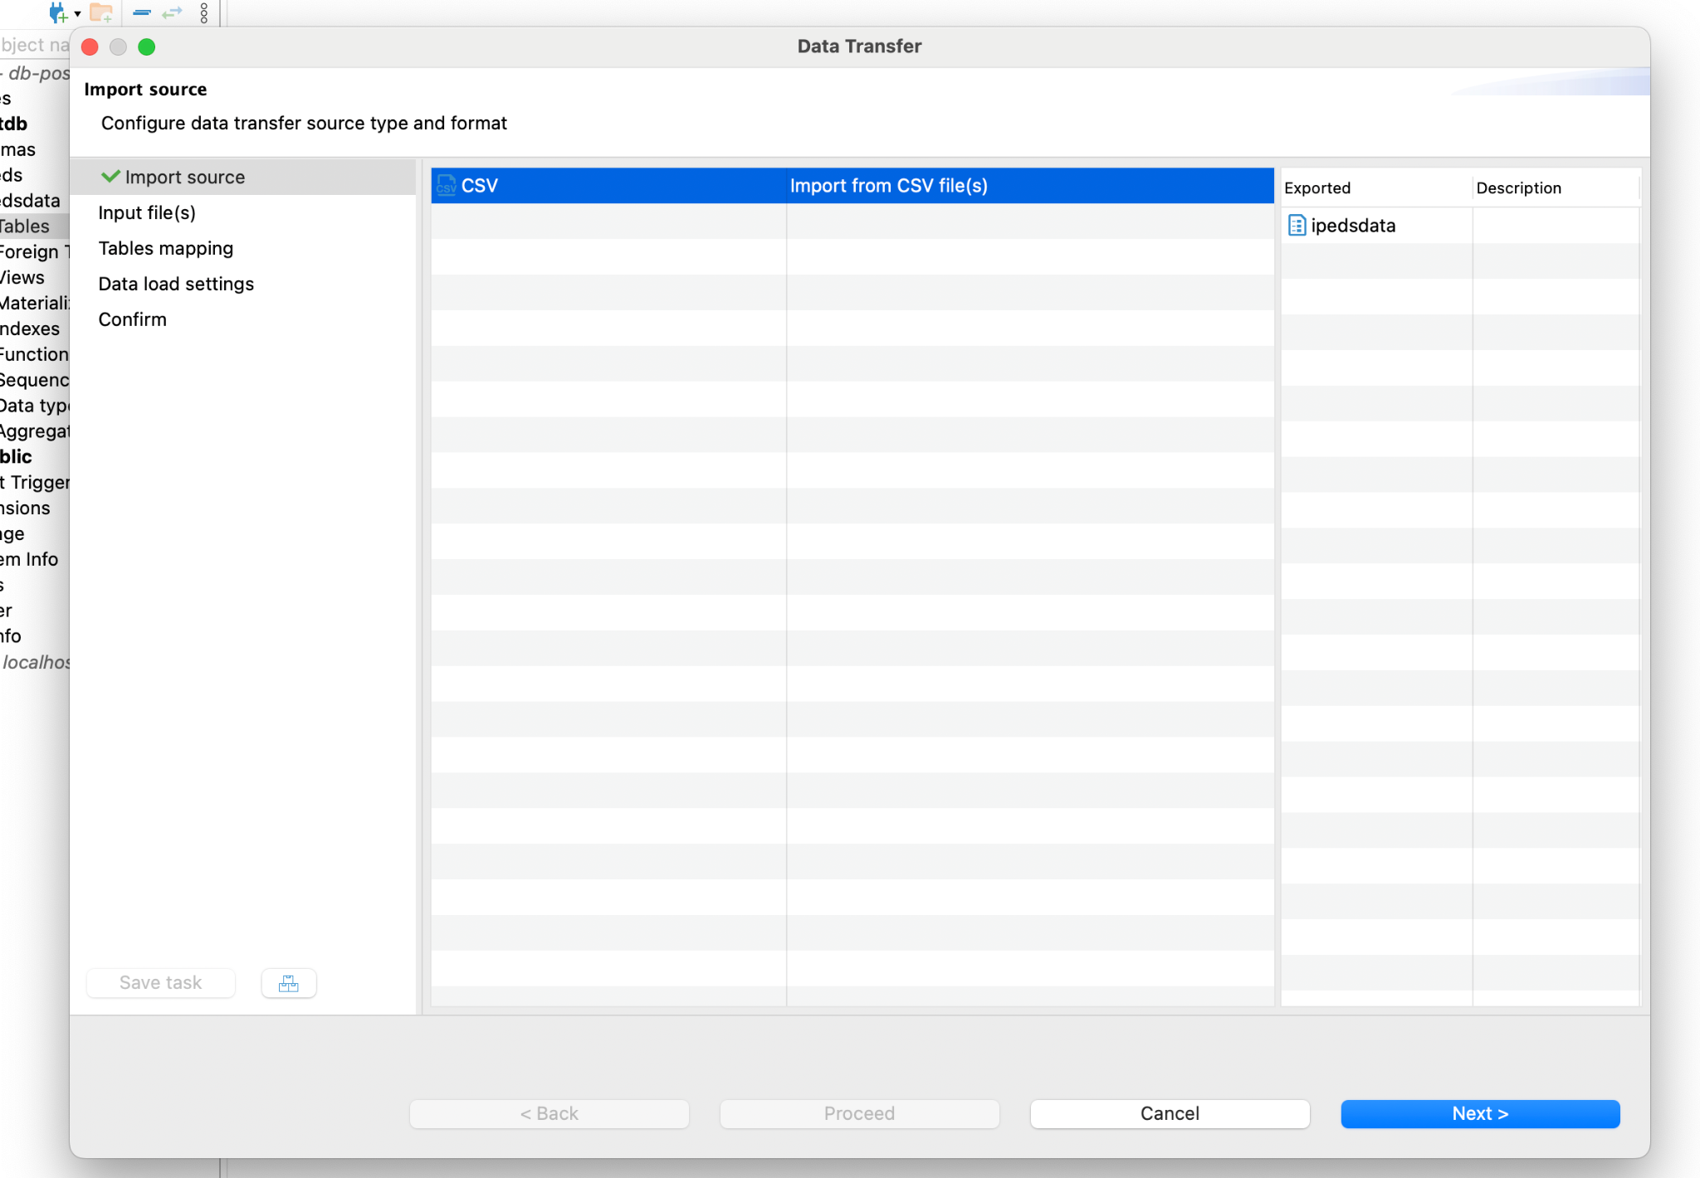

*Fig. 29; Selecting CSV file to import*

1. Once the file is selected and is ready you can see the configurations of the data which are by default selected. We can change the column properties as needed in this step.

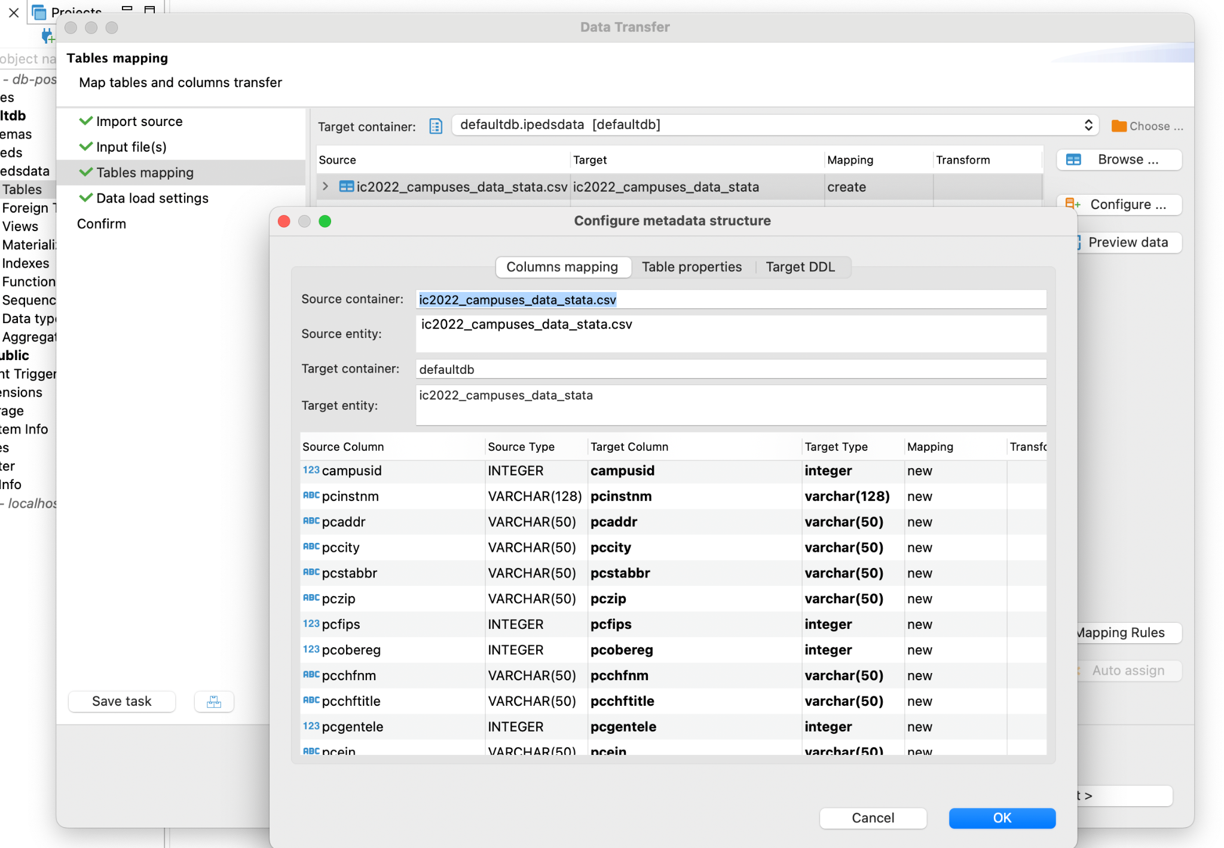

*Fig. 30; Configuring Table and Column properties*

1. Once all the properties are selected and modified, we can click ‘proceed’ as seen in the below figure.

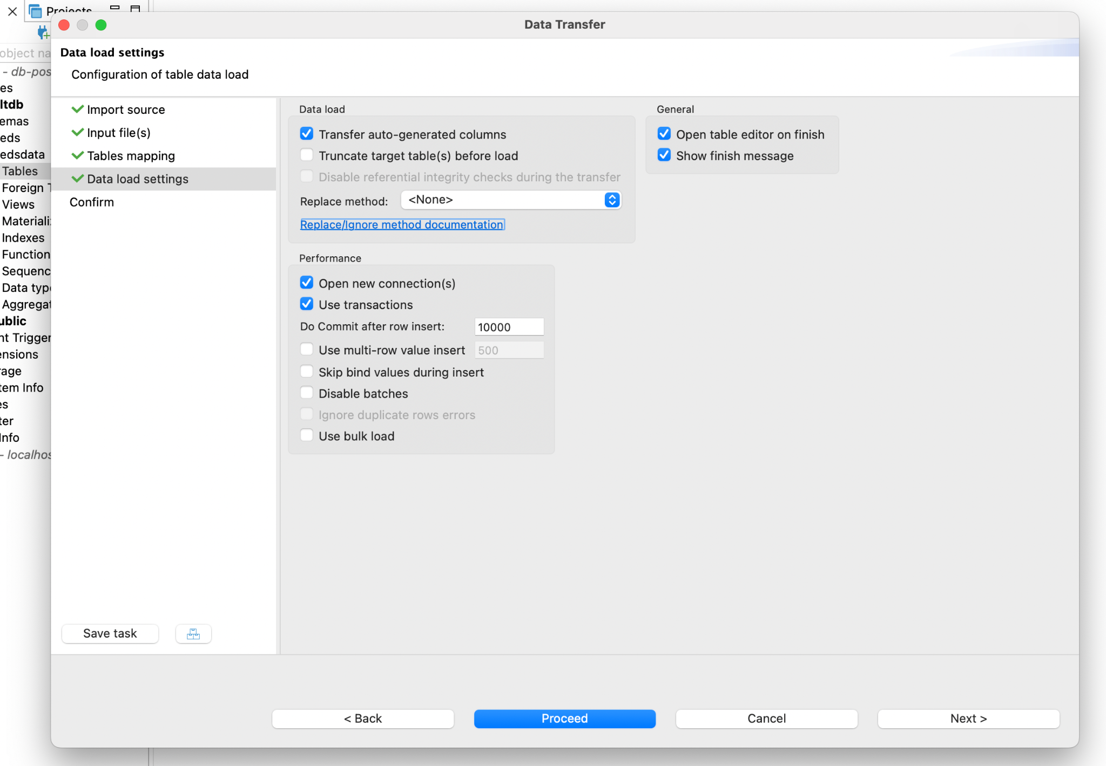

*Fig. 31; Confirm the properties to load*

# **Appendix B: Installing Dbeaver and Connecting to Database**

We can download the DBeaverLite v24.0 tool from the [official site](https://dbeaver.com/download/). Once installed follow below steps to connect to a postgres db. Details are also outlined clearly in [official site documentation.](https://dbeaver.com/docs/dbeaver/Database-driver-PostgreSQL/)

Once the tool is open and ready, click on the new database connection. It will prompt the following options for SQL, among which is postgreSQL as seen in the below image.

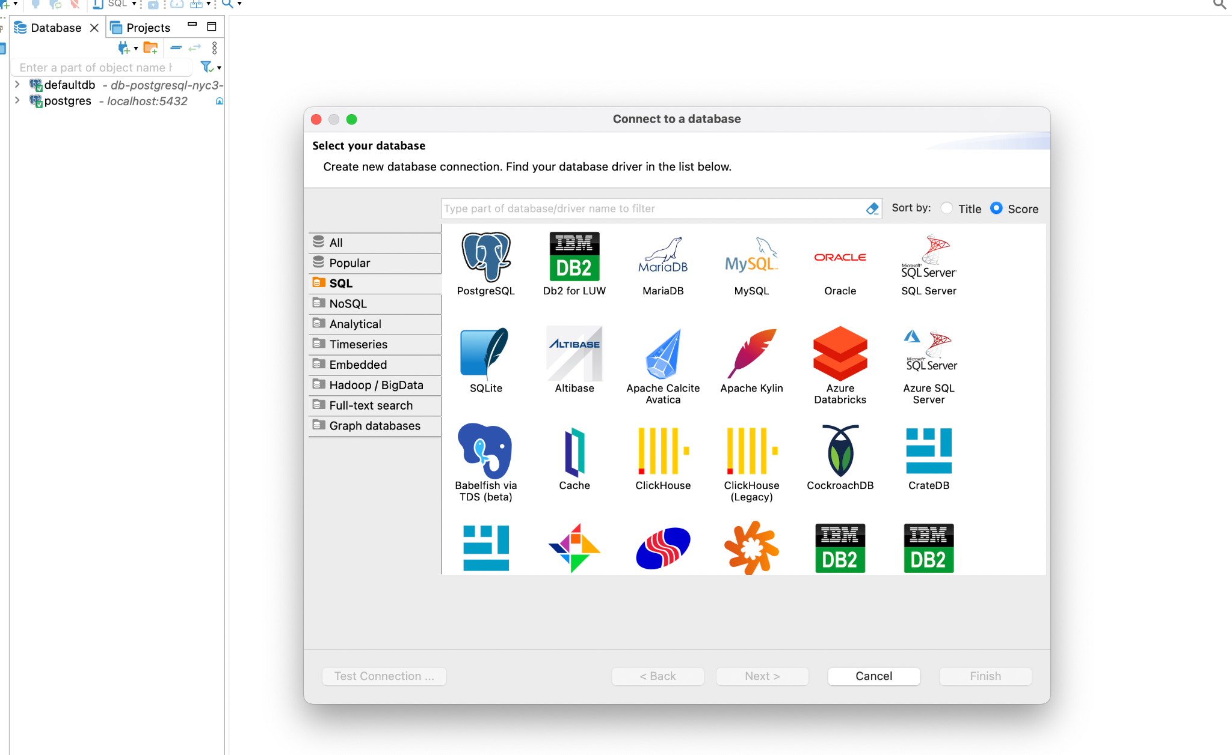

*Fig. 32; Connect to a database*

Click on the postgresql and fill the connection details with host, port, username, password, database as shown in below image. If you haven’t hosted a database then connect to localhost to use the bot on your local system.

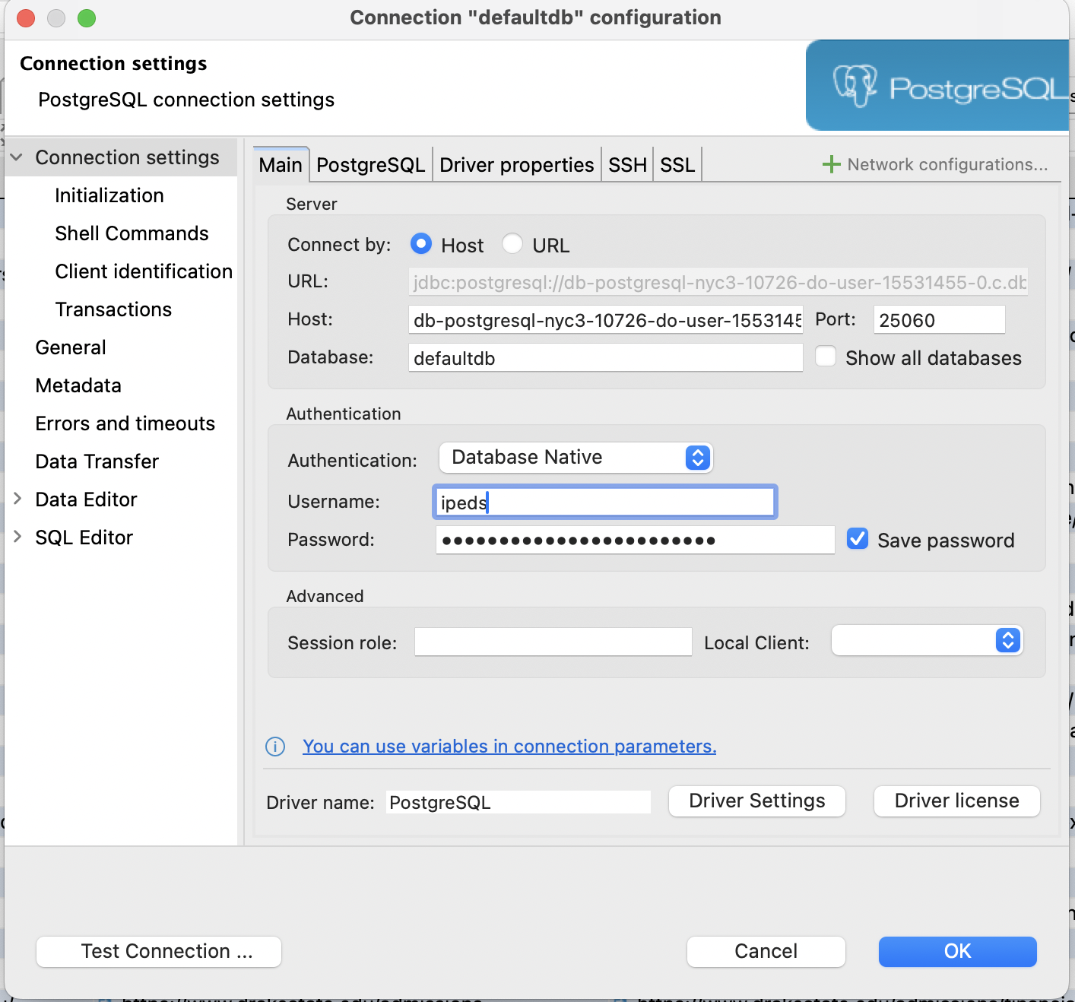

*Fig. 33; Connection details*

Connection details for postgres Ipeds db:

* Host:db-postgresql-nyc3-10726-do-user-15531455-0.c.db.ondigitaocean.com
* Port: 25060
* db: defaultdb
* User: ipeds
* Password: y64HegZEqX3c

After connecting to the database, you will have the db and list of schemas if any, as shown in below figure. We can load the tables into related schemas for our use.

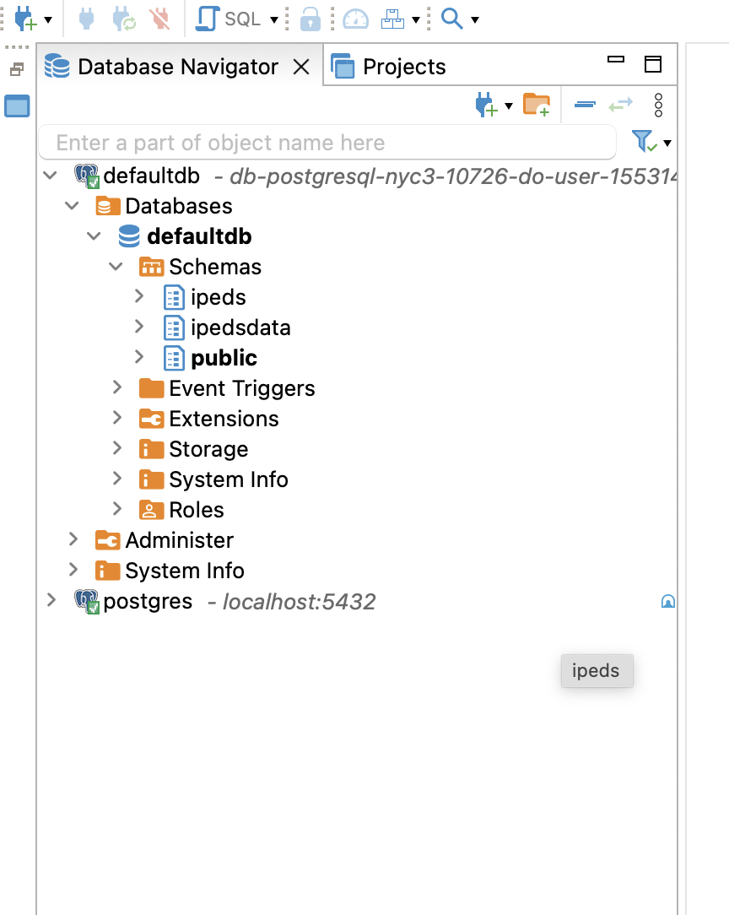

*Fig. 34; UI of a connected DB in Dbeaver*

To verify, if you can connect to the database using python, execute the following python script in your environment.

pip install psycopg2

import psycopg2

try:

connection = psycopg2.connect(

dbname="your_database",

user="your_username",

password="your_password",

host="your_host",

port="your_port"

)

print("Connected to database successfully!")

except psycopg2.Error as e:

print("Error connecting to database:", e)

cursor = connection.cursor()

cursor.execute("SELECT * FROM your_table")

rows = cursor.fetchall()

for row in rows:

print(row)

connection.close()

# **Appendix C:** **Sample Dataset and Data Dictionary**

We have imported 20 tables in total for our project into the postgres database "defaultdb" under the "ipedsdata" schema, which are downloaded from IPEDs. The following is the list of tables we have. All the tables are related to university characteristics, finance, or enrollment etc.

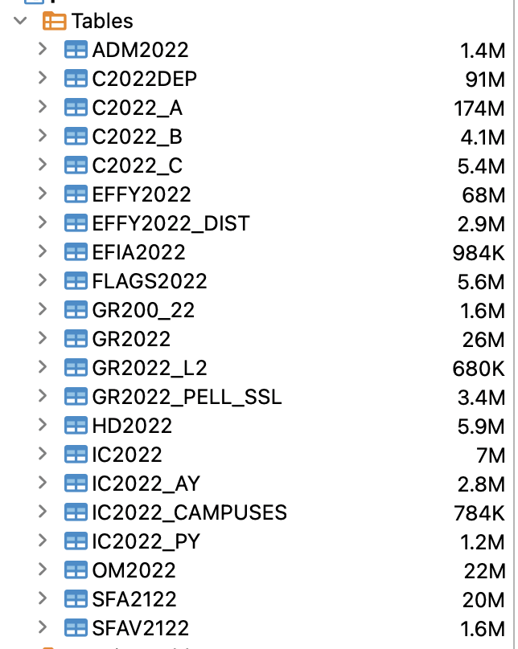

*Fig. 35; List of Tables under “ipedsdata” schema in “defaultdb”*

Let's look at a sample table, HD2022, which has institute characteristics like name, address, telephone, URL, etc. The figure below (*Fig. x*) shows a sample of data from the HD2022 table.

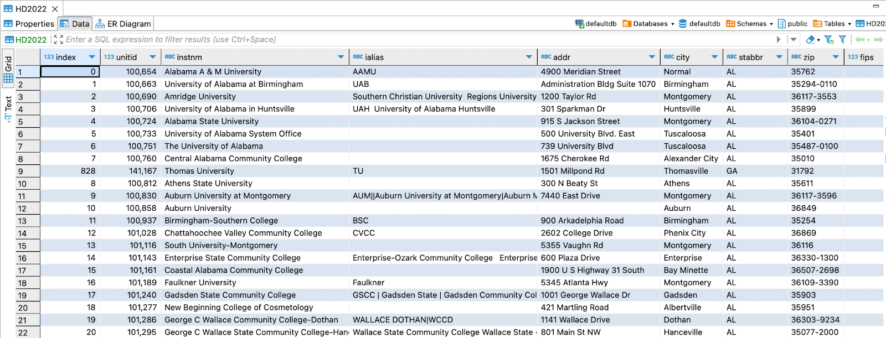

*Fig. 36; Sample Data of Table ‘HD2022’*

Now, as the fields are abbreviated and not apparent to humans or even LLM models, a data dictionary is available for each table. We can either load the data dictionary in the database to automate its use or have a CSV file and use it in Python code. The example data dictionary of the table HD2022 is below.

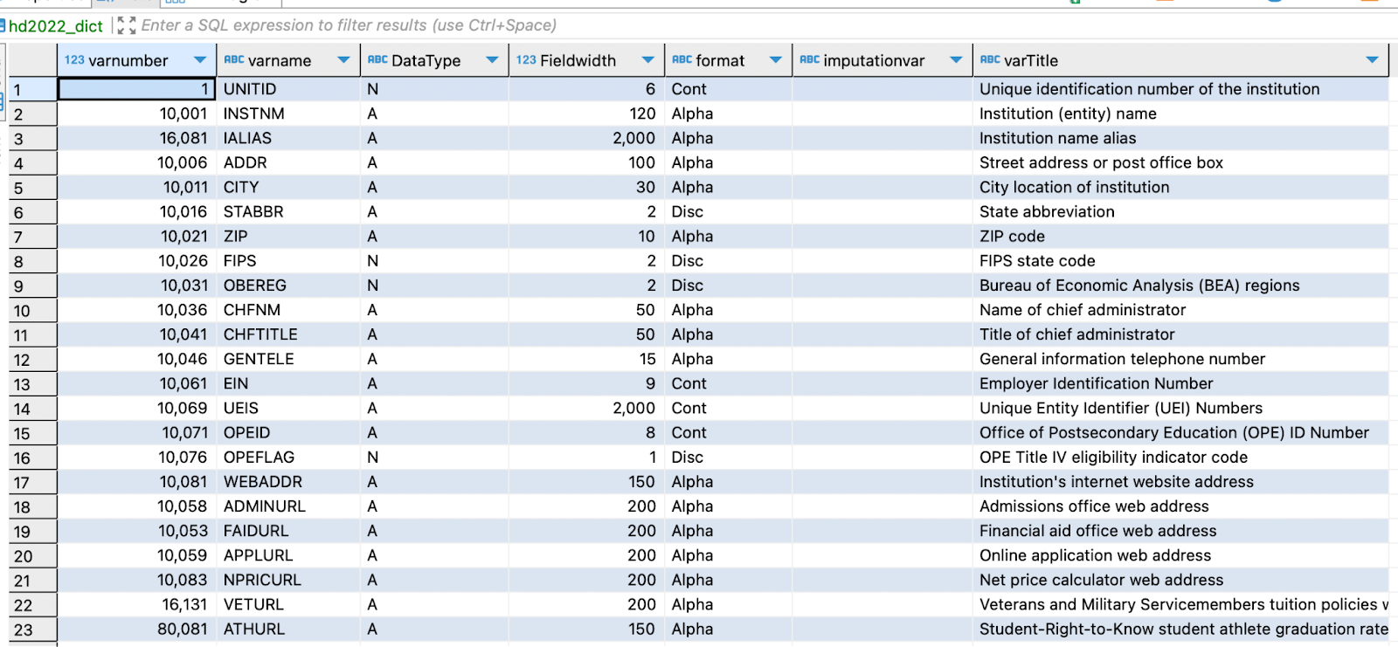

*Fig. 37; Sample Data Dictionary for Table ‘HD2022’*

As we can see above, the data dictionary has only seven fields, each with a name, type, field width, and description. In the rows, the characteristics of columns in the table HD2022 are explained. In the field Varname, we can see the names of columns from the HD2022 table, and in the field varTitle, we can see the short descriptions of the respective columns.

# **Appendix D: LLM Environment Setup and Code Execution**

**Hardware:**

* RAM (16 GB)
* GPU (16GB or higher)

**Software:**

* Windows 10, Linux or Mac (OS)
* Python 3.10 or higher
* Visual Studio Code application (Version 1.87.2)
* PostgreSQL Database (Version 8.2)

**Storage**:

* 512 GB or 1 TB

Necessary steps to establish the environment for implementing the RAG model:

* **Cloning the Repository**: The repository needs to be cloned to access the necessary codebase. Execute the following command in your terminal

*git clone* [*https://github.com/hemadataworksai/ipedsllm.git*](https://github.com/hemadataworksai/ipedsllm.git)

* **Setting up a Virtual Environment**: Before proceeding with the project setup, a virtual environment must be created to isolate dependencies:

**Windows:**

*# Create a virtual environment*

*python -m venv venv*

*# Activate the virtual environment*

*venv\Scripts\activate*

**macOS/Linux**

*# Create a virtual environment*

*python3.11 -m venv venv*

*# Activate the virtual environment*

*source venv/bin/activate*

* **Installing Project Dependencies:** Project dependencies can be installed using pip. Run the following command:

*pip install -r requirements.txt*

* **Configuration:** Create a .env file in the root directory of the project and populate it with the required details:

*OPENAI_API_KEY=YOUR_OPENAI_API_KEY*

*DB_URL=YOUR_DATABASE_URL*

*LANGCHAIN_TRACING_V2=YOUR_LANGCHAIN_TRACING_V2_SETTING*

*LANGCHAIN_ENDPOINT=YOUR_LANGCHAIN_ENDPOINT*

*LANGCHAIN_API_KEY=YOUR_LANGCHAIN_API_KEY*

Ensure to replace placeholders with appropriate values for *YOUR_OPENAI_API_KEY,*

*YOUR_DATABASE_URL,*

*YOUR_LANGCHAIN_TRACING_V2_SETTING,*

*YOUR_LANGCHAIN_ENDPOINT*

*YOUR_LANGCHAIN_API_KEY*

* **Running the DataworksAI chatbots**
  + **Langchain DataworksAI chatbot:** To run the Langchain DataworksAI chatbot with *Streamlit*, execute the following command:

*streamlit run src/langchain_DataworksAI chatbot/components/main.py*

* + **LlamaIndex DataworksAI chatbot:** To run the LlamaIndex DataworksAI chatbot with Streamlit, execute the following command:

*streamlit run src/llamaIndex_chat/components/main.py*

# **Appendix E: Open AI account**

Developers may use API keys to access OpenAI's API and include powerful natural language processing (NLP) functionalities into their applications.

***Configuring an API Key for OpenAI:***

1. Register: You must first create an account on the [OpenAI](https://openai.com/blog/openai-api) website to receive an OpenAI API key.
2. API Key Generation: To generate an API key, go to the API area of your account after creating an account and logging in. You might need to accept the terms of service and indicate the access level.
3. Management of API Keys: Using the OpenAI dashboard, you can monitor your account, manage your API key, and see usage data after it has been generated.
4. Integration: Lastly, include your API key in your application's code, making sure that it is used and stored safely and in accordance with best practices.

To use the OpenAI API, you must authenticate using your API key. After completing the authentication process, you can send HTTP requests to the OpenAI API server by submitting API requests to the specified endpoints.

The selected pricing plan and access level will usually determine the cost structure and usage limitations for using the OpenAI API to access the GPT-3.5 Turbo Large Language Model (LLM). The number of tokens processed, API requests made, and other use data could all impact pricing. Furthermore, OpenAI might offer tiered pricing schemes with various usage allowance levels and associated fees.

### 

# **Appendix F: Langsmith**

# **Appendix G: Streamlit**

# Appendix H: SQL Queries For Testing

[Minimum Viable Prototype Plan](https://drive.google.com/drive/folders/1VOK1zsmifkrinoXuDSThM5008-r01cG3)

# Appendix I: Install Requirements

# Appendix J: Testing DataworksAI chatbot

# [22]Appendix K: Research Paper Outstanding Items

# To Do

All

* Please install Git and follow the instructions for installation and environment setup. If the installation does not work or the instructions are unclear, please comment on the document so the Lang-LLama team can improve the write-up.
* Please install DBeaver and connect to the database via Python and DBeaver. Try sample queries from the SQL queries from Git feedback to the DB team if the instructions are unclear.
* Read the document end to end; for clarity and readability, provide feedback.
* Flag technical concepts not covered, review existing glossary Items, and add additional items for Devi to improve and collate.
* Run a few tests suggested by the Testing team and capture responses in the format requested.
* Request colleagues in your network for feedback on the document; both technical and English language experts will be helpful.

DB-Team

* Code review SQL scripts from Pardhu and add it to Git Folder
* Fill in the contents of the materials in the Data Engineering quadrant. Identify the techniques in LangChain and LLama and move it to the Data Engineering Quadrant after consulting with the Lang-LLama team team
* Solicit Feedback from the team regarding the clarity of the Data Engineering Quadrant write-up

Testing Team

* Collate Testing information in the document and Appendix for the Research Paper team
* Add relevant testing documents in the Project folder per the Research Paper team
* Recommendations

Lang-LLama team

* Add Modeling Quadrant information
* Add Software Engineering Quadrant information
* Work with the DB team to identify which concepts and Techniques fit in Data Engineering Quadrant src/langchain_cha

Research Paper team

* Organize the research document, format, and add transitions between ideas and other missing items.

https://aws.amazon.com/blogs/machine-learning/generating-value-from-enterprise-data-best-practices-for-text2sql-and-generative-ai/

* Add Modelling Quadrant information consulting Lang-LLama team
* Add Testing Information consulting Lang-LLama and Testing team team
* Add Software Engineering Quadrant information consulting Lang-LLama team
* References
* Glossary
* Identify owners for missing information and follow through
* Organize folder structures and store supporting information in a folder

# Missing Items

.

* When was LangChain introduced, LlamaIndex, Open source etc, by whom?
* Why are we using LangChain and LlamaIndex since all the buzz is about Meta’s LLAMA2?
* Define Supervised fine-tuning, In-Context Learning and Reinforcement Learning with Human Feedback (RLHF) training and why they are essential for this project[23]
* Hallucinations
* Define Chat Model
* How were the original DB and tables created?
* Why Digital Ocean?
* Digital Ocean has few other offerings. Why not MongoDB or MySQL

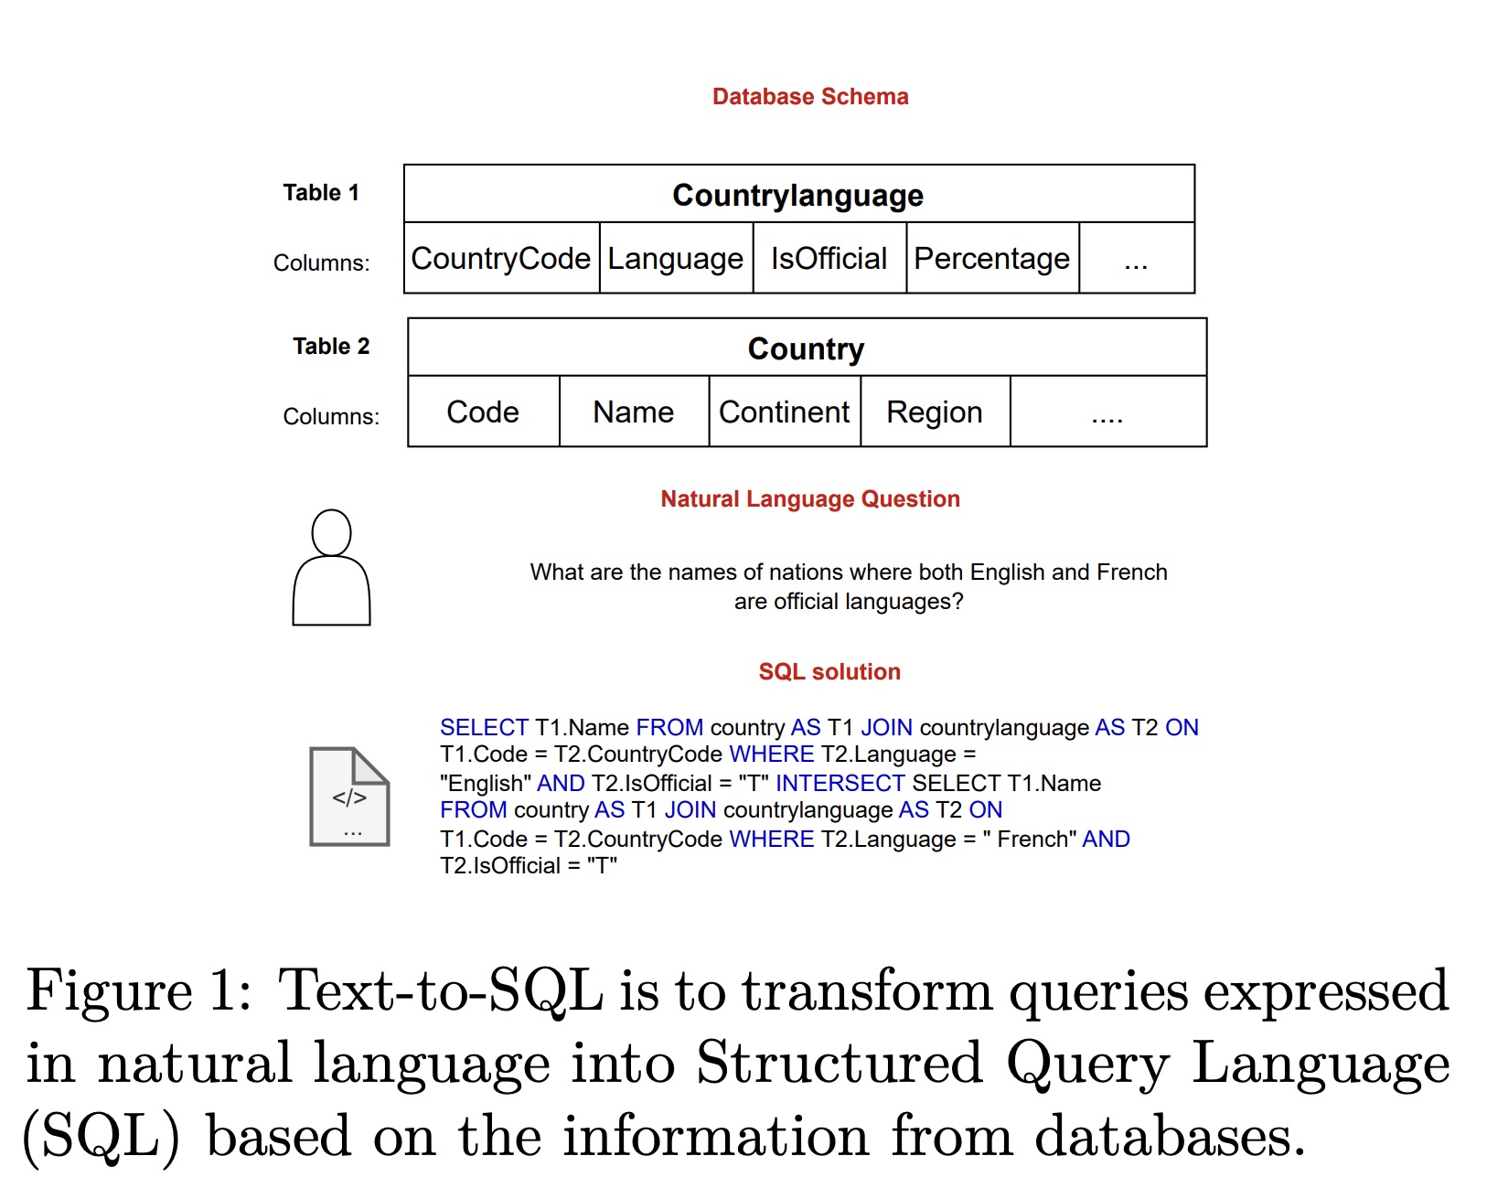

Fig Reference: https://arxiv.org/pdf/2306.00739.pdf

## 

Next Steps:

3 approaches – mark mentioned (Json, html, training queries)

Extensive Testing – for new approach this is not used

Low code – pardhu (add) - limitations (limits exceeded), what needs to be improved, chaining is used? - it will deliver ten answers with a free membership. And Chaining is not used.

Prompt engineering - We can provide suggested questions. We don't have any other option to give prompting, but we can set the temperature for this bot when you build it.

<https://app.chatlab.com/#/bots/>

Future Work for Robo Assist How to?

1. Yes or no Chaining- No Chaining
2. Limited Tables and Data Dictionary - It will only accept one html file at a time and will provide replies from that html file itself; it is fully independent of prior uploaded html files. And it will deliver ten answers with a free membership.

Mark question:   
   
Give improper names to columns and check the answers. It should fail. Then give the same improper column names and assign them proper abbreviation. This time it has to give correct solutions based on those column abbreviations.

Answer:

Due to the limitations of the [Robo assist (chat lab)](https://app.chatlab.com/#/login), we're constrained to testing only one HTML file at a time. This means we can't directly compare the behavior of two HTML files simultaneously. In the scenario provided by our sponsor for the capstone project, we're tasked with testing the impact of column names on the accuracy of generated solutions.

If we intentionally input incorrect column names in one HTML and check the answers, there's a high likelihood of failure in generating correct solutions. This failure occurs because the system misinterprets the data due to the improper column names.

However, we can mitigate this issue by following a two-step approach:

Testing with Incorrect Column Names: Initially, we'll deliberately use improper column names to observe how the system behaves and to ensure that it fails to provide accurate solutions. This step helps us validate the importance of correct column names in the data processing pipeline.

Testing with Proper Abbreviations: After identifying the failure with incorrect column names, we'll correct the column names by assigning proper abbreviations. Once the HTML file is loaded with the corrected column names, we'll retest the system. This time, the system should generate accurate solutions since it can now interpret the data correctly.

It's crucial to note that there's no dependency or chaining between the HTML files with incorrect column names and those with corrected column names. Each HTML file operates independently in the testing environment.

1. Introduction - (what is the final goal of our project – preparing DataworksAI chatbot using these models so and so)
2. Pretraining

2.1 Pretraining Data:(ipeds data, structure of data that is stored)

2.2 Training Details: (how text to SQL works the whole overview)

2.3 OpenAI Pretrained Model Evaluation (Token Limits, all info in the below link) (https://platform.openai.com/docs/models/continuous-model-upgrades)

1. Fine-tuning: (LangChain vs LlamaIndex)

3.1 Lang-chain

I) Techniques: Prompt Templates, Extraction with Pydantic, Vector Embeddings,

DAG (Directed Acyclic Graphs), Few shot prompts (example selector (Semantic Similarity Example Selector from langchain) – few shot examples, embeddings, Chroma vector store, concept of ‘k’), Output Parsers (StrOutputParser), Chaining (table chain, get_chain (this is the custom chain/function we’ve created where everything comes into place)).

II) Modules: Chat Open AI, Open AI tools (create_extraction_chain_pydantic), Prompts (ChatPromptTemplate, MessagesPlaceholder, FewShotChatMessagePromptTemplate, PromptTemplate), langchain utils (SQLDatabase), langchain tools (QuerySQLDatabaseTool), langchain chains (create_sql_query_chain), langchain memory (ChatMessagehistory)

III) Streamlit

IV) Tracing with langchain (Trace of the queries)

3.2 LLama-Index

I) Techniques:

II) Modules:

1. Discussion

4.1 Learnings and Observations

4.2 Limitations (knowledge base resulting in token consumption in both langchain & llama, data quality(table structures, constraints, encoded values for columns) )

1. Conclusion

Appendix

1. <https://arxiv.org/pdf/2308.15363.pdf>
2. <https://medium.com/dataherald/how-to-connect-llm-to-sql-database-with-llamaindex-fae0e54de97c>
3. https://learning.oreilly.com/library/view/developing-apps-with/9781098152475/ch01.html
4. https://arxiv.org/pdf/2402.06196.pdf
5. https://docs.aws.amazon.com/sagemaker/latest/dg/jumpstart-foundation-models-fine-tuning.html#jumpstart-foundation-models-fine-tuning-instruction-based
6. https://arxiv.org/pdf/2312.10997.pdf
7. Liu, J. (2024, January 10). Introducing query pipelines - LlamaIndex Blog - Medium. Medium. https://medium.com/llamaindex-blog/introducing-query-pipelines-025dc2bb0537
8. https://www.llamaindex.ai/blog/introducing-query-pipelines-025dc2bb0537
9. https://a.co/d/gzpW6La
10. https://a.co/d/cCcHh62
11. [*https://www.digitalocean.com/products/managed-databases*](https://www.digitalocean.com/products/managed-databases)*?*
12. https://learning.oreilly.com/library/view/building-llm-apps/9781835462317/text/ch006.xhtml#technical-requirements-4
13. https://learning.oreilly.com/library/view/building-llm-apps/9781835462317/text/ch006.xhtml#technical-requirements-4
14. https://learning.oreilly.com/library/view/building-llm-apps/9781835462317/text/ch006.xhtml#technical-requirements-4
15. https://learning.oreilly.com/library/view/building-llm-apps/9781835462317/text/ch006.xhtml#technical-requirements-4
16. https://ts.llamaindex.ai/
17. https://learning.oreilly.com/library/view/transfer-learning-for/9781617297267/OEBPS/Text/ch01_Azunre.htm#pgfId-1081140
18. Azunre, P. (2021, 08 31). Transfer Learning for Natural Language Processing. What is transfer learning? <https://learning.oreilly.com/library/view/transfer-learning-for/9781617297267/OEBPS/Text/ch01_Azunre.htm#pgfId-1081140>
19. https://arxiv.org/pdf/1706.03762.pdf
20. https://arxiv.org/pdf/1706.03762.pdf
21. Caelen, O., & Blete, M. (n.d.). Developing Apps with GPT-4 and ChatGPT, 2nd Edition. O’Reilly Online Learning. <https://learning.oreilly.com/library/view/developing-apps-with/9781098168094/ch01.html#demystifying_the_tokenization_and_prediction_steps>
22.
23. https://learning.oreilly.com/library/view/building-llm-apps/9781835462317/text/ch004.xhtml#technical-requirements-2